CallTek Engineering Request
System Type | QIS | Name of Requester | Alex
Request Date | June 10, 2024 | Name of Engineer | IT DEV
Approved by | Jane Salumbides | Approval Date | June 10, 2024

Task
Identified Issue or Feature request | We had many instances where we encountered missing entries when adding the scores in QIS. After we click on save, if we entered an incorrect batch number and/or failed to enter the batch number the entries are lost on the current form. The following is the possible fix.  - Update the New Hire Communications Training Evaluation Form  - Set the Batch number as fixed.  - Exclude the batch number when adding the result.  - Update the New Hire Technical Training Evaluation Form  - Set the batch number as fixed.  - Exclude the batch number when adding the result.  Currently, this is how we do the form in QIS.  FOR New Hire Communications Training Evaluation  - We will Select Communication And Customer Service Training Form, then Set the batch number and click on Search Button.  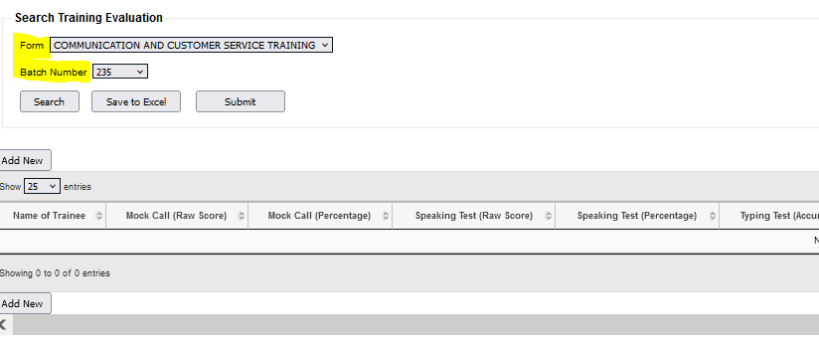  - We will then select Add New button and a pop-up box will show. We will have to input all the details including the Batch number.  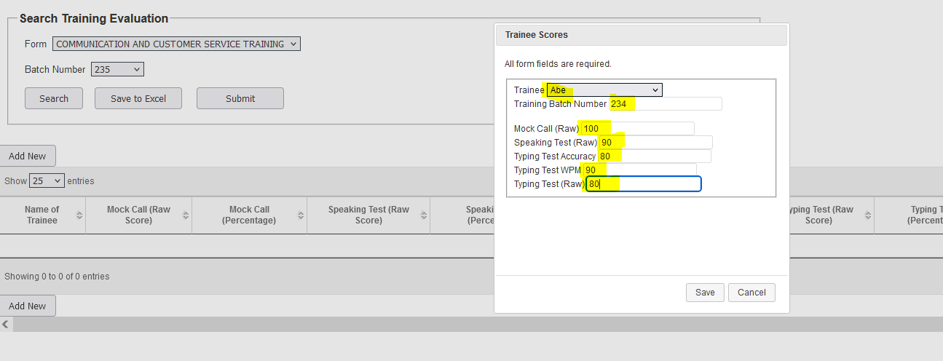  FOR New Hire Technical Evaluation:  - We will Select New Hire Technical Training Form, then Set the batch number and click on Search Button.  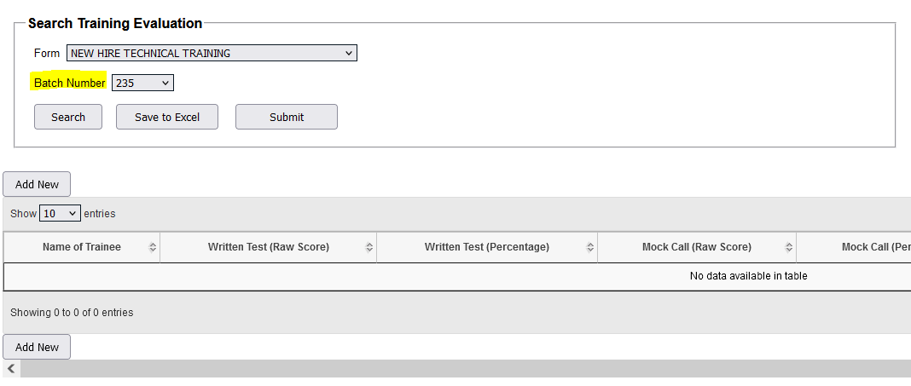  - We will then select Add New button and a pop-up box will show. We will have to input all the details including the Batch number.  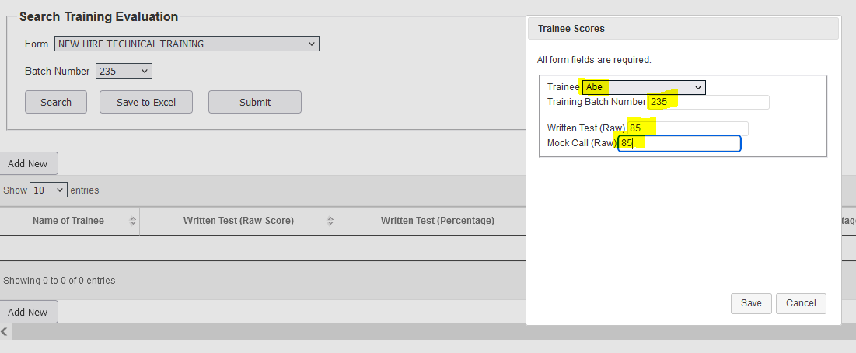
Goal | The goal is to prevent any missing entries when adding the evaluation scores. This way we will not resort to manual submission of the result and also we will no longer ask IT Dev for correction of the entries.
Root Cause and Findings
Fix implemented
Regression Test Performed
Side effects of Fix
Solution Acceptor Comments

