CallTek Engineering Request

System Type | HKI Live Chat | Name of Requester | Justin
Request Date | December 6, 2024 | Name of Engineer
Revision Date |  | Approved by
Version No. |  | Approval Date

TASKS
Identified Issue or Feature Request | *Account: HKI Chat Support  - Client is looking for some chat support solutions (although they did not specify where they will put the chat client, but Ms Jessy wants us to show them what we currently have integrated for Airtower).  - Dev will modify the current Live Chat admin Name to “Hotel Internet Services”  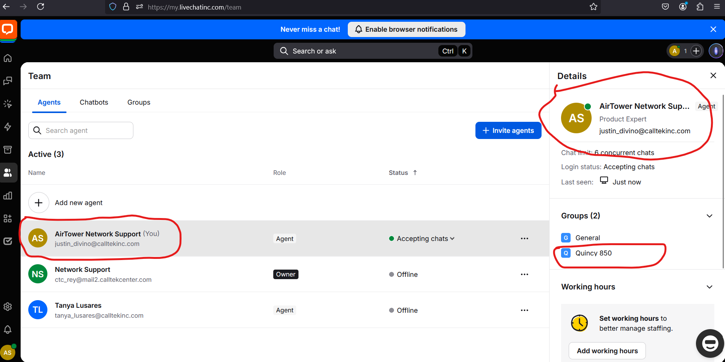  - The Group name must be changed from “Quincy” to “Hotel A”.. (Quincy is Airtower’s property and we need it changed to another name).  - Support Chat must autoreply with a generic technical support name and remove (Airtower)  - After the Support Chat, it must automatically create a ticket in CAS assigned to HKI vendor. Ticket Assignee can be named as “livechat”. (CAS ticket specific requirements can be anything for now as long as we can see the entire chat conversation from the body since this is just for demo purposes only)  - Install Live Chat plugin to current rxglab portal. Use the below portal and credentials  Portal url: https://rxglab2.cosmos.us.com/portal/login/  RXG Lab access: https://rxglab2.cosmos.us.com/admin  Un: ctc_dev  Pw: Calltek2024!  (I will attach the SSH key in this email)
Goal | *Create a Chat Support Environment with CAS Integration for HKI client (same logic with Airtower’s Live Chat). This is for demo purposes only to the client.

