System Type | CAS | Name of Requester | Shelley
Request Date | Dec 13, 2024 | Name of Engineer
Approved by |  | Approval Date

Task
Identified Issue or Feature request | To add RMA Tab and Quotes Tab in our Performance Dashboard next to Meeting and Events: Follow up Due today.
Goal | To easy monitor/track our RMA and Quote Tickets broken down using Follow up Type:
Root Cause and Findings | In the RMA Tab –  It will show Tickets with Reported Issue: RMA, with the following Follow up Type:  Should only include ALL Open tickets.  It should show the total case count of each Follow up Type – total case count are just open tickets with RMA as the Reported Issue with following Follow up Type:  - RMA – To be Processed  - RMA – Ticket Submitted  - RMA - Waiting for Replacement  - RMA – Waiting for site to return the defective unit  - RMA - Pending installation/ For installation  See below Screenshot on how it should look like in the Dashboard = SS1  It’s the same with Meeting and Events: Follow up Due today, when any of the # of ticket is click it will open another tab for the ticket details, wherein we have the option to set the date range, Vendor, Chain and Severity, Issue, Solution, Owner/Agent’s name, with the following ticket details can be found in = SS2  SS1  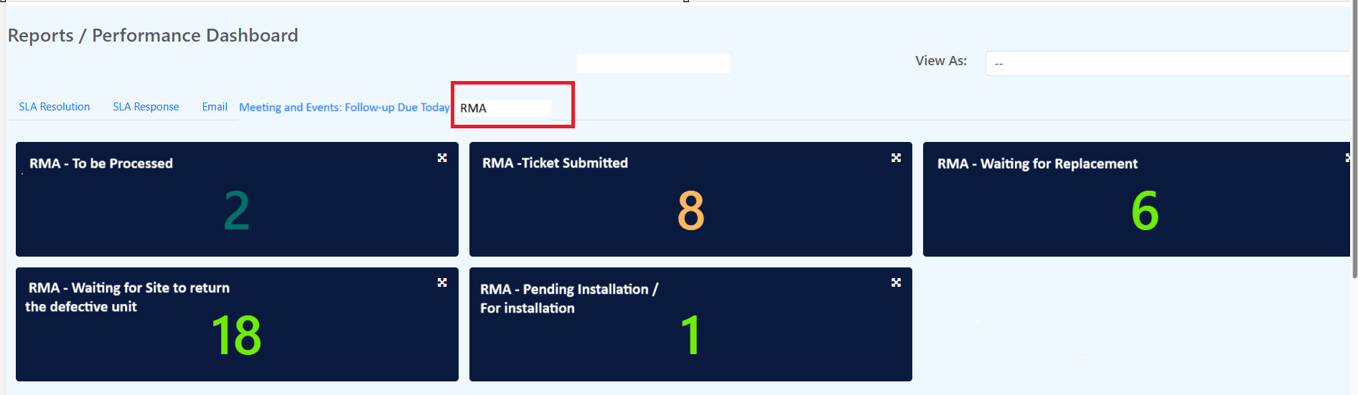  SS2  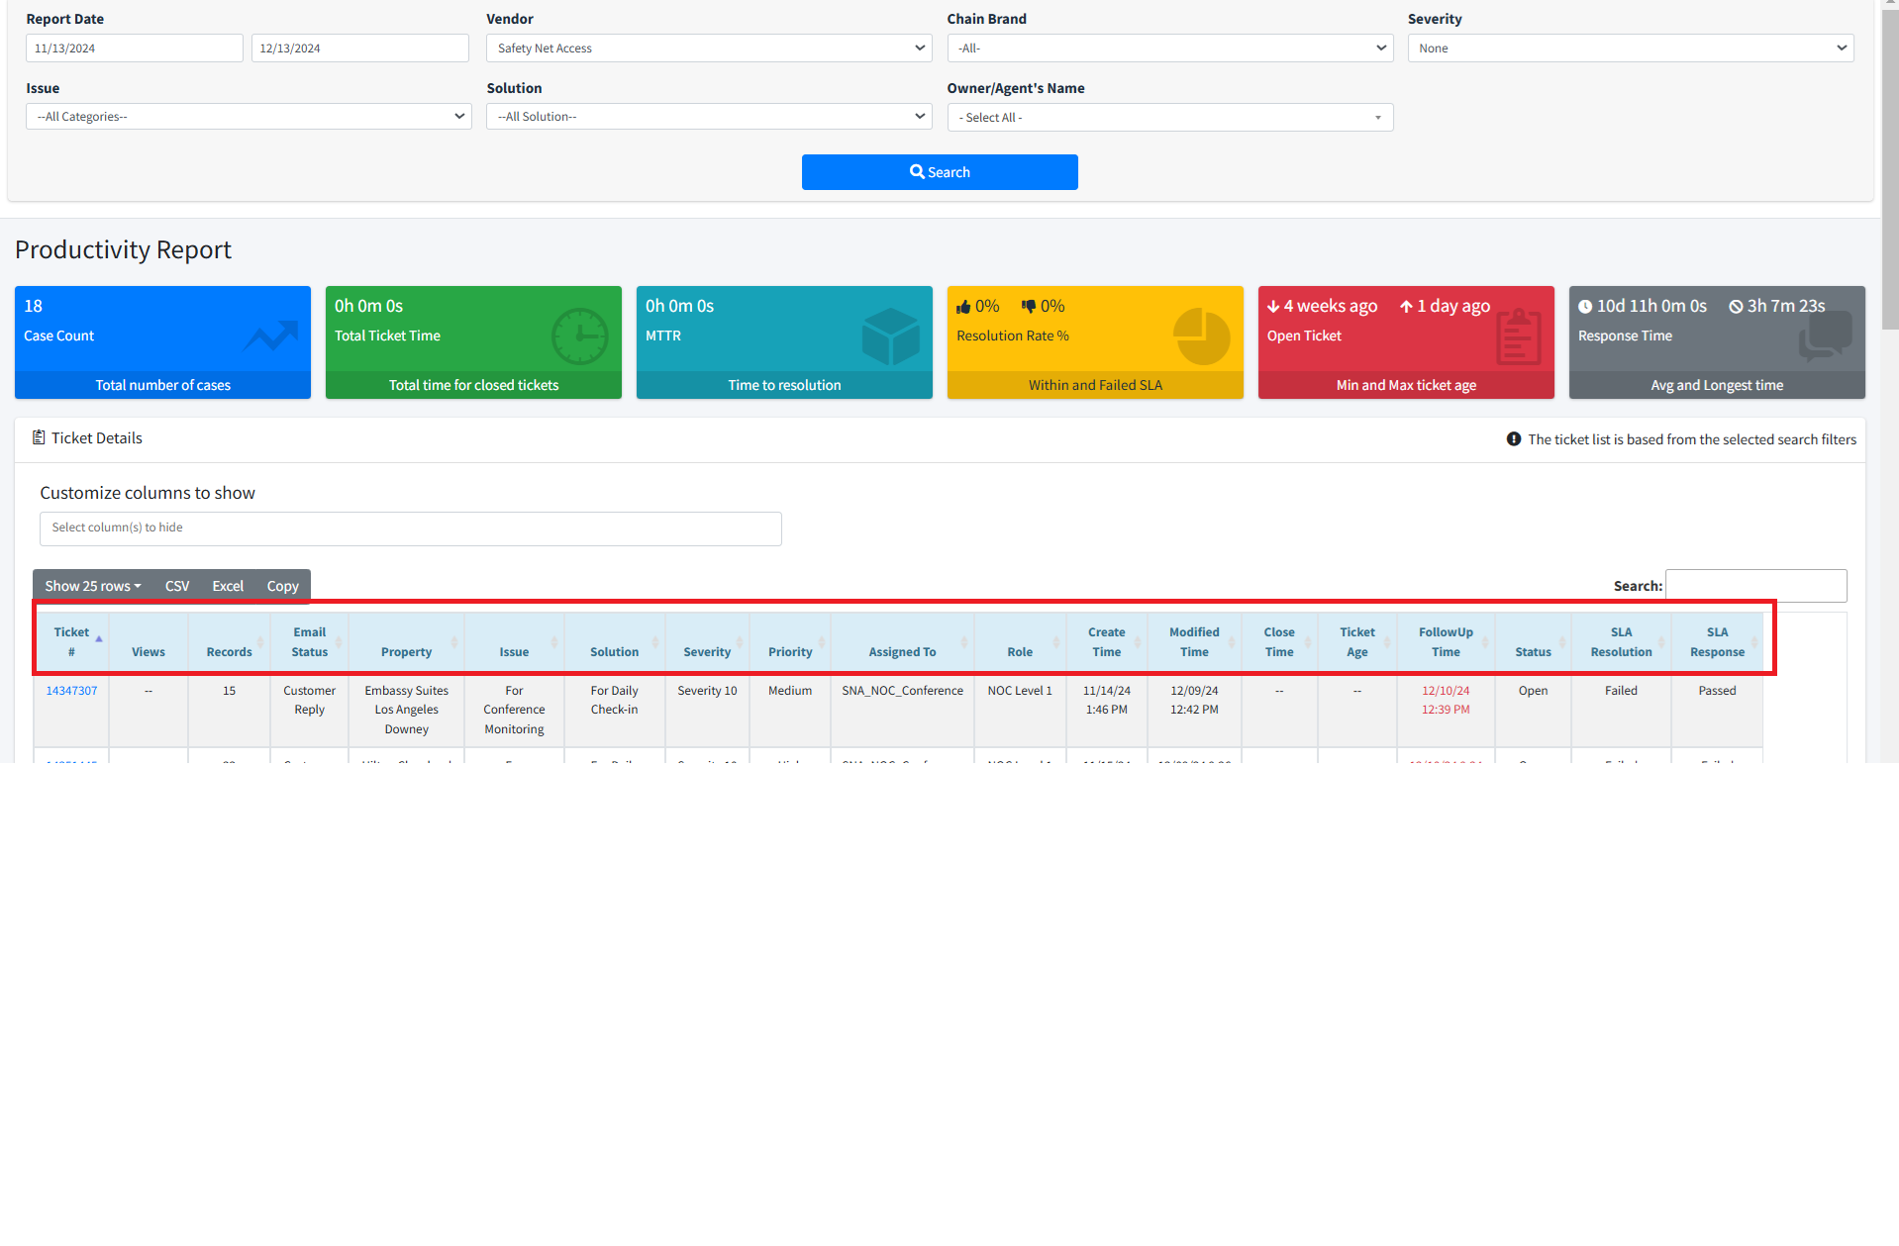  In Quote’s TAB. – this will be beside RMA Tab.  It will show Tickets with Reported Issue: Quotes Request with the following Follow up Type:  Should only include ALL Open tickets.  It should show the total case count of each Follow up Type – total case count are just open tickets with Quote Request as the Reported Issue with following Follow up Type:  Quote - To be Submitted  Quote - Request Submitted  Quote - Waiting for Site's Approval  Quote - Quote approved - waiting for the unit  Quote - Pending unit Install  Quote - Install Completed  See below Screenshot on how it should look like in the Dashboard = SS3  SS3  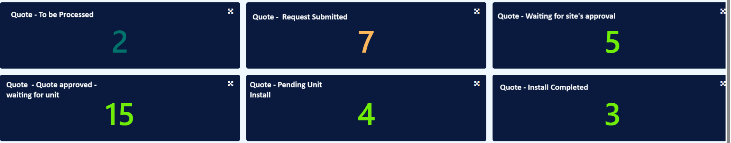  It’s the same with Meeting and Events: Follow up Due today, when any of the # of ticket is click it will open another tab for the ticket details, wherein we have the option to set the date range, Vendor, Chain and Severity, Issue, Solution, Owner/Agent’s name, with the following ticket details can be found in = SS4  SS4:  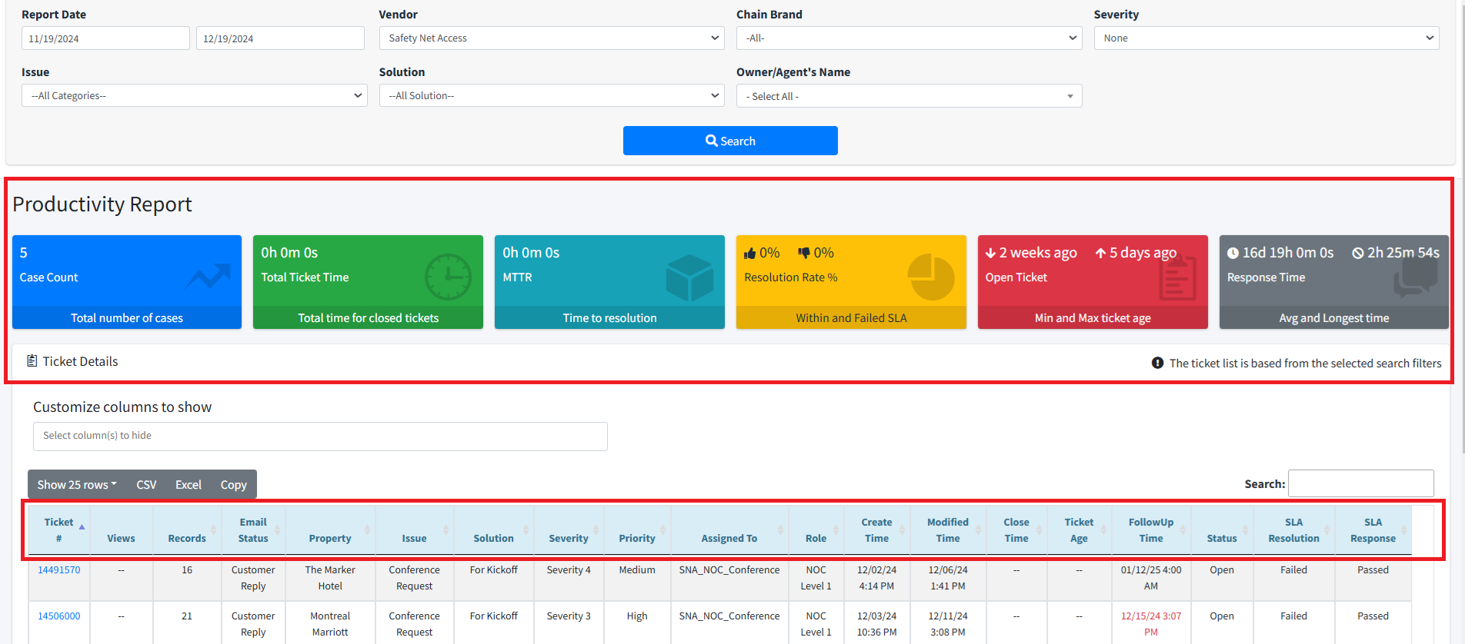
Fix implemented
Regression Test Performed
Side effects of Fix
Solution Acceptor Comments

