CallTek Engineering Request
System Type | QIS_External_Management_Dashboard | Name of Requester | Lance
Request Date | Dec 20, 2024 | Name of Engineer
Approved by |  | Estimated Completion
Approval Date

Task
Identified Issue or Feature request | Client should have access to Management Dashboard in External QIS  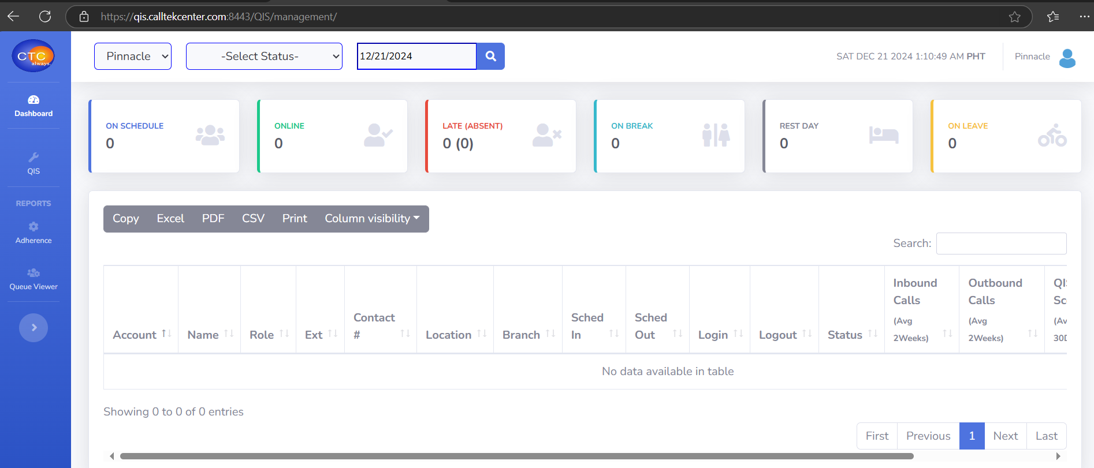  Link: https://qis.calltekcenter.com:8443/QIS/management/  - Current option available for client access.  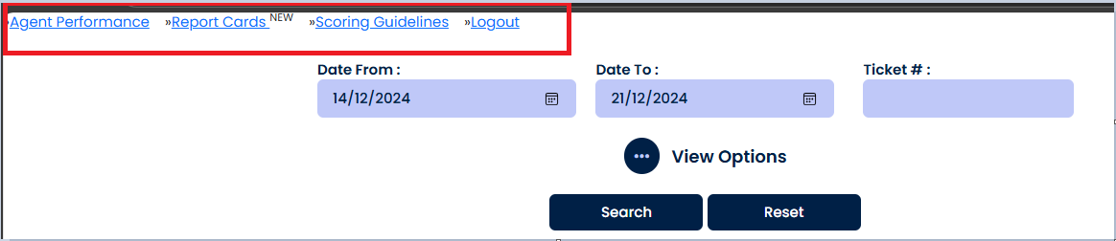  - Add link in Vendor Level user access in QIS to open or redirect to the Management Dashboard that will only allow to view agents.  - Access should only be limited to their own account. For this case, it’s for Pinnacle.  - List of users to have access to the said link:  - Amy Hannesson ahannesson@pinn360.com  - Thomas Hawkins thawkins@pinn360.com  - Blake Gregg bgregg@pinn360.com  - James Abissin jabissin@pinn360.com
Goal | For client(s) to have access to Management Dashboard in QIS to check daily attendance, call count and QA score.
Root Cause and Findings
Fix implemented
Regression Test Performed
Side effects of Fix
Solution Acceptor Comments

