CallTek Engineering Request
System Type | CAS | Name of Requester | Joei
Request Date | December 25, 2024 | Name of Engineer | IT DEV
Approved by | OMS | Approval Date

Task
Identified Issue or Feature request | We need to track down cases per guest name, room number, caller type for Marriott reporting purposes.  The client needs this by January 2025.
Goal | To be able to input guest name/room when creating a case or searching a case in CAS.  To be able to generate case reports using guest names/room number and caller type, category and subcategory as well.
Root Cause and Findings | Example:  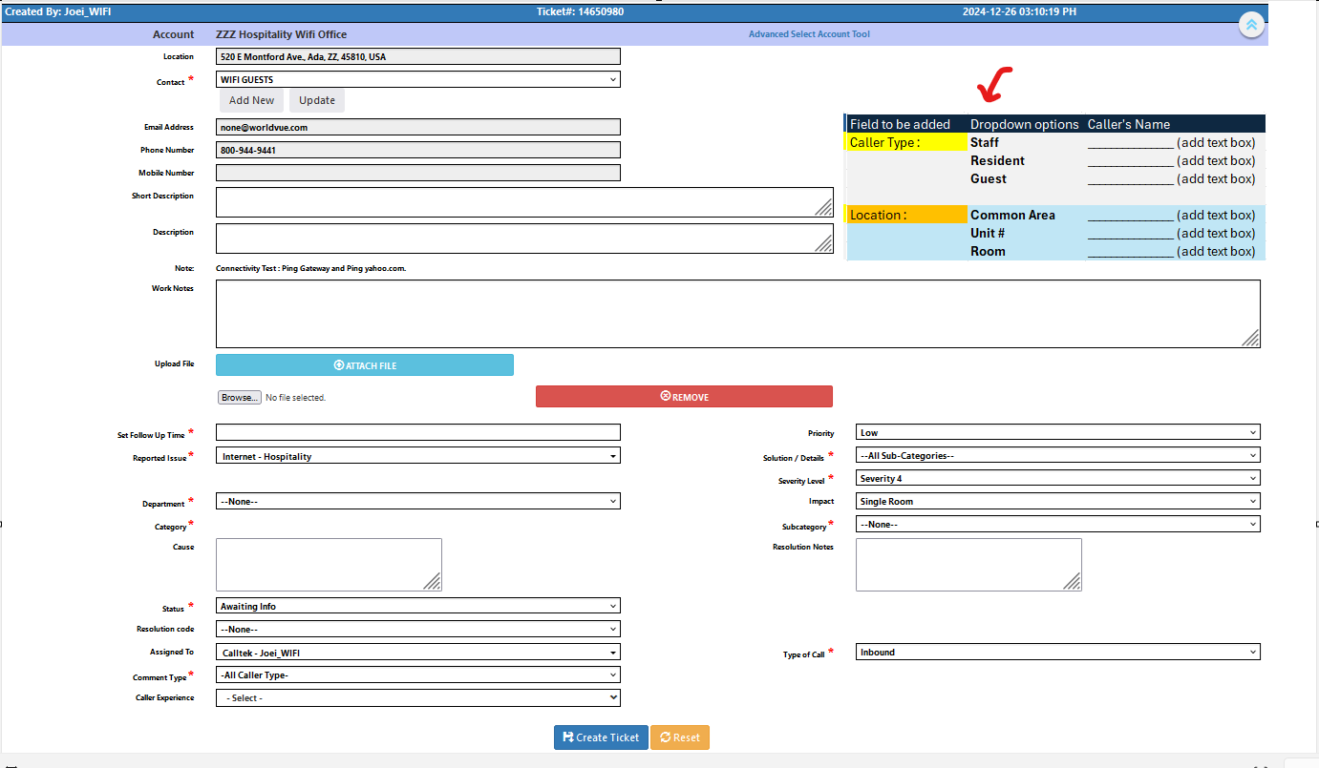
Fix implemented
Regression Test Performed
Side effects of Fix
Solution Acceptor Comments

