CallTek Engineering Request

System Type | Vista Splash Page | Name of Requester
Request Date | December 9, 2024 | Name of Engineer
Revision Date |  | Approved by
Version No. |  | Approval Date

TASKS
Identified Issue or Feature Request | *Account: Vista NOC  *Property Name: Best Western Harrisburg, PA  *client requested to change the color of the Hotel Logo  *site is using HP and splash page must in cosmos  Splash Page  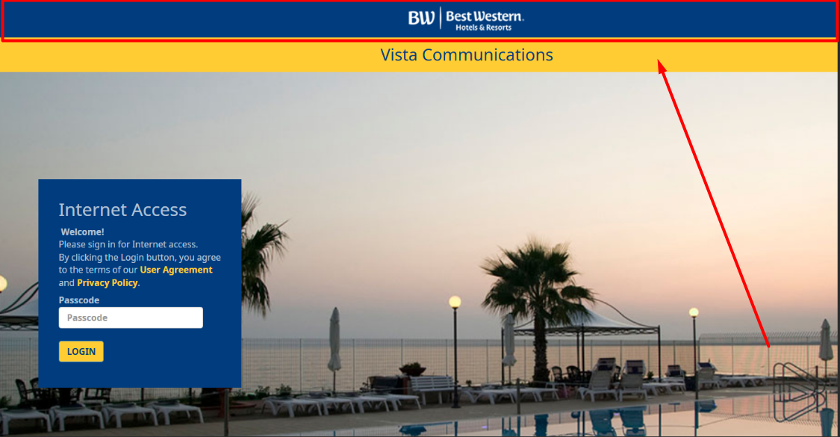  Landing Page  Redirect to this URL:https://portals.vistacommunications.com/vistaportal/best_western_harrisburg_pa/index.php?path=%l&mac=%m&ip=%c&%i  HP IP: 50.229.23.138  This is the current portal page as mention, as selected below this to be replaced by the image above.  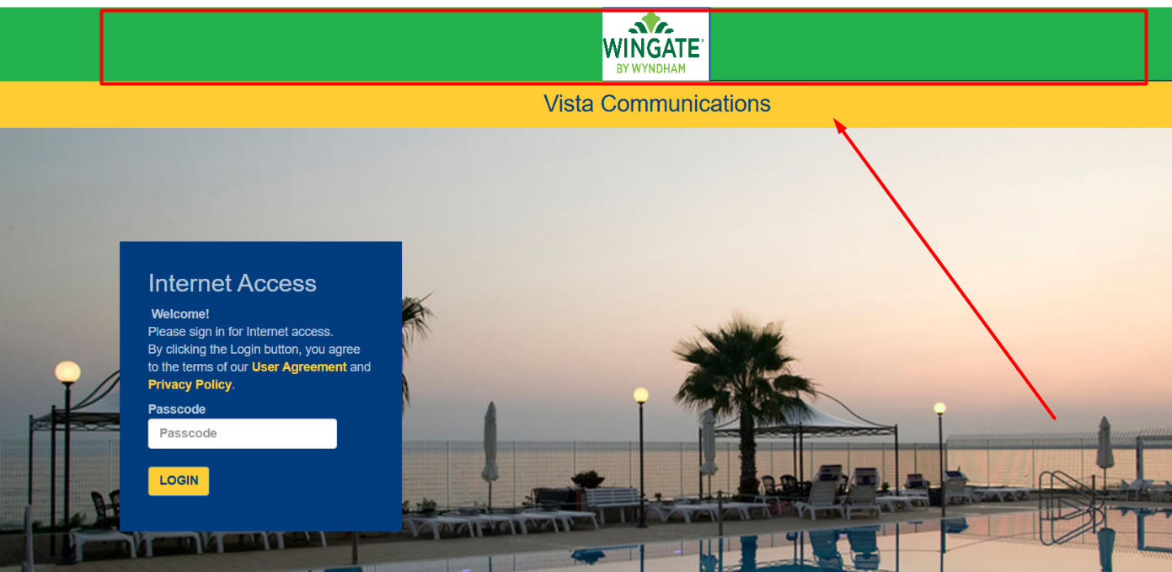  The property has transitioned from the Best Western brand to Wingate by Wyndham, and they would like to update the logo on the current portal page. Additionally, they need to change the upper blue color to the green shown in the reference image attached below.
Goal | *Custom Splash Page Request for Best Western Harrisburg, PA

