System Type | CAS | Name of Requester | Shelley
Request Date | Jan 20, 2025 | Name of Engineer
Approved by |  | Approval Date

Task
Identified Issue or Feature request | To add Dispatch Tab in our Performance Dashboard next to Quote Tab
Goal | To easy monitor/track our For Dispatch Tickets broken down using Follow up Type:
Root Cause and Findings | In the Dispatch Tab  It will show Tickets with the following Follow up Type:  Should only include ALL Open tickets.  It should show the total case count of each Follow up Type – total case count are just open tickets with following Follow up Type:  - Dispatch – Waiting for Approval  - Dispatch – For Tech Dispatch  - Dispatch – For SOW Creation  - Dispatch - SOW for T4 Review  - Dispatch – Secured & Scheduled  - Dispatch – To be Rescheduled  See below Screenshot on how it should look like in the Dashboard = SS1  It’s the same with Meeting and Events: Follow up Due today, when any of the # of ticket is click it will open another tab for the ticket details, wherein we have the option to set the date range, Vendor, Chain and Severity, Issue, Solution, Owner/Agent’s name, with the following ticket details can be found in = SS2  SS1  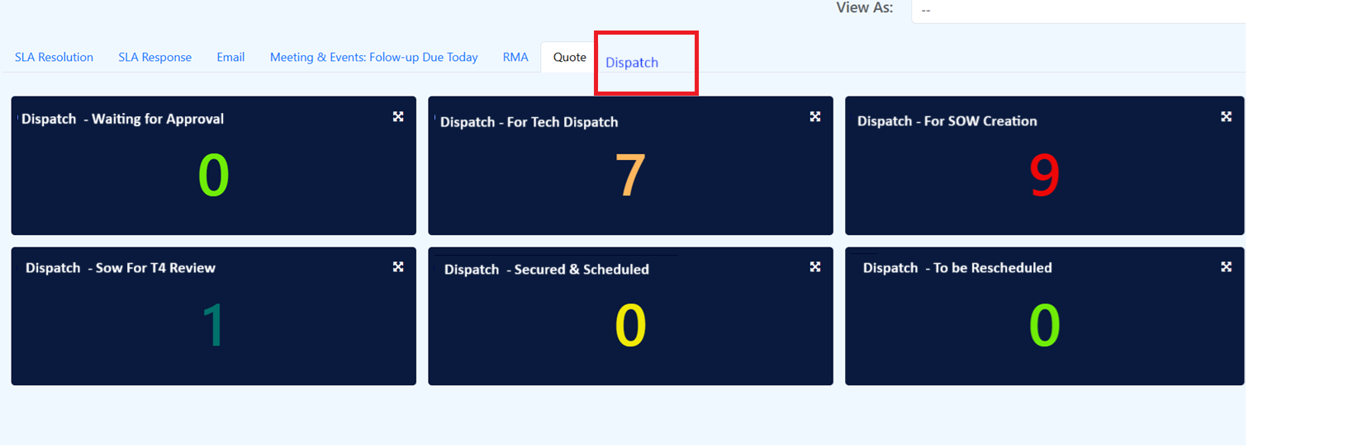  SS2  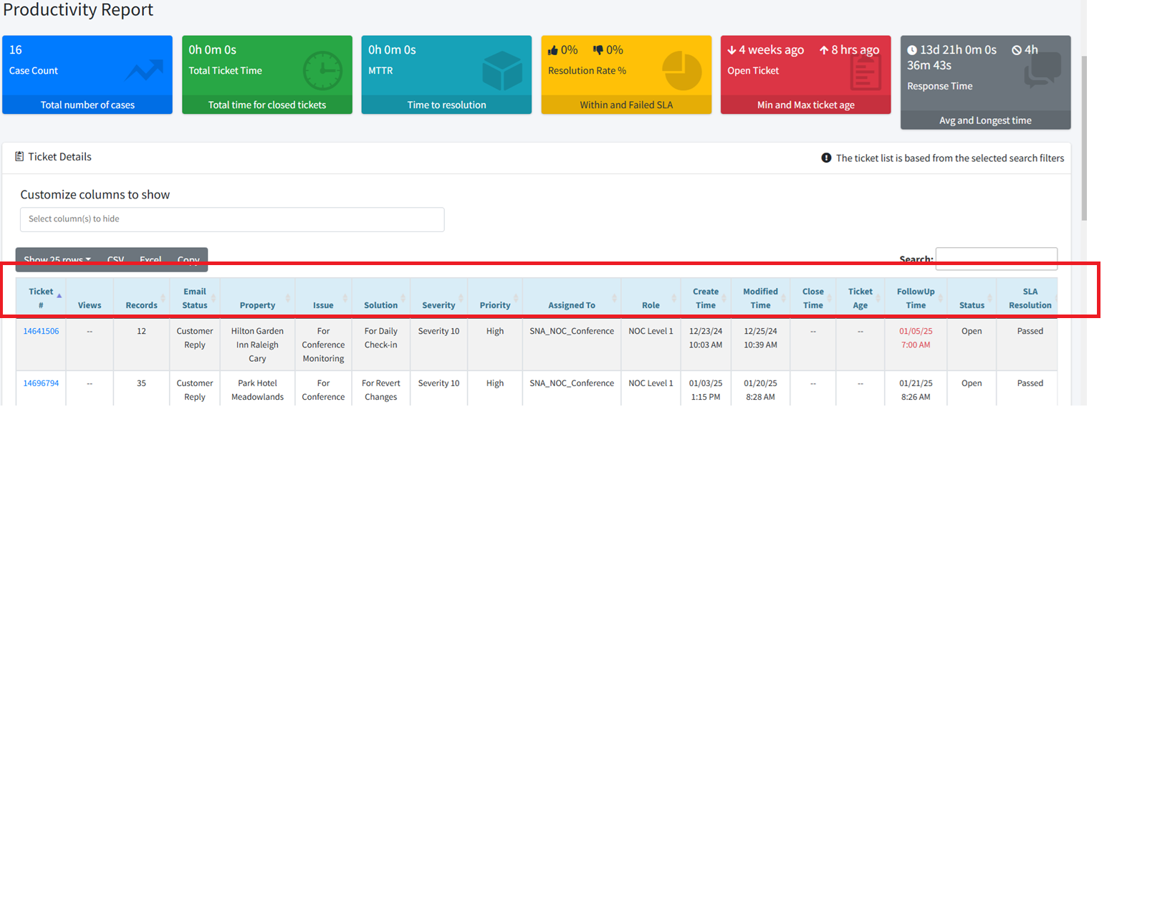
Fix implemented
Regression Test Performed
Side effects of Fix
Solution Acceptor Comments

