CTC BPO Inc. Engineering Request
System Type | Green Octopus – QA Form | Name of Requester | Cathleen
Request Date | 1/29/2025 | Name of Engineer | Franz / Karl
Approved by |  | Estimated Completion
Approval Date

Task
Identified Issue or Feature request | Add a QA Scorecard form in Green Octopus web access to allow the Project Managers and/or Remote Engineers to evaluate the quality of the work done based on the checklist/punchlist that is associated to the work order.  We need to start this with the new vendor – Ambient.  - Add an option to Settings menu to create a QA form as it may vary from one project to another.  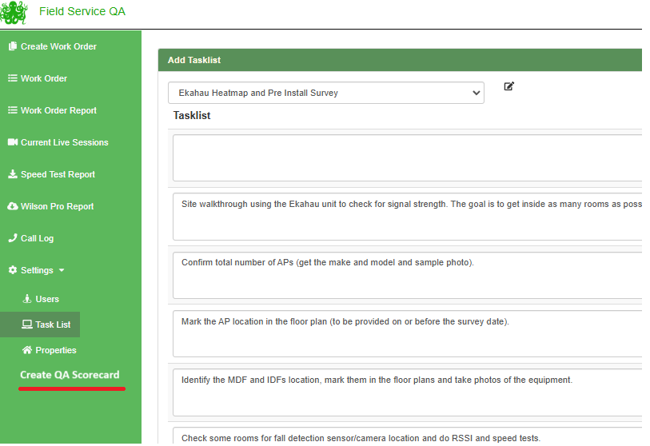  - Use QIS Assessment form as reference in creating the scorecard -  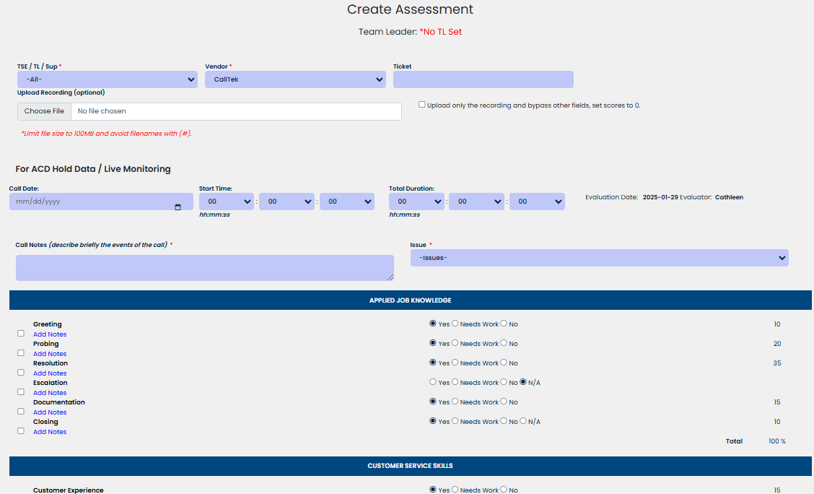  - Select the QA form required for the checklist when creating the work order.  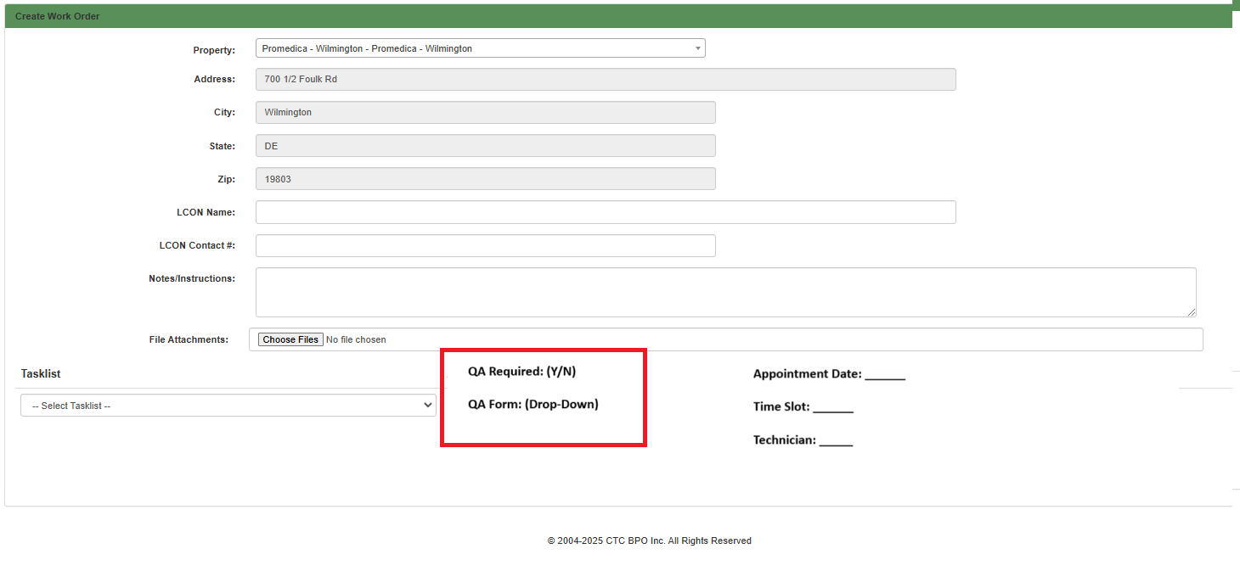  - Add a QA Scorecard Button to the Checklist to allow the PM or Remote Engineer to input the score. Clicking on Create Evaluation will display the QA Form with the Work Order details –  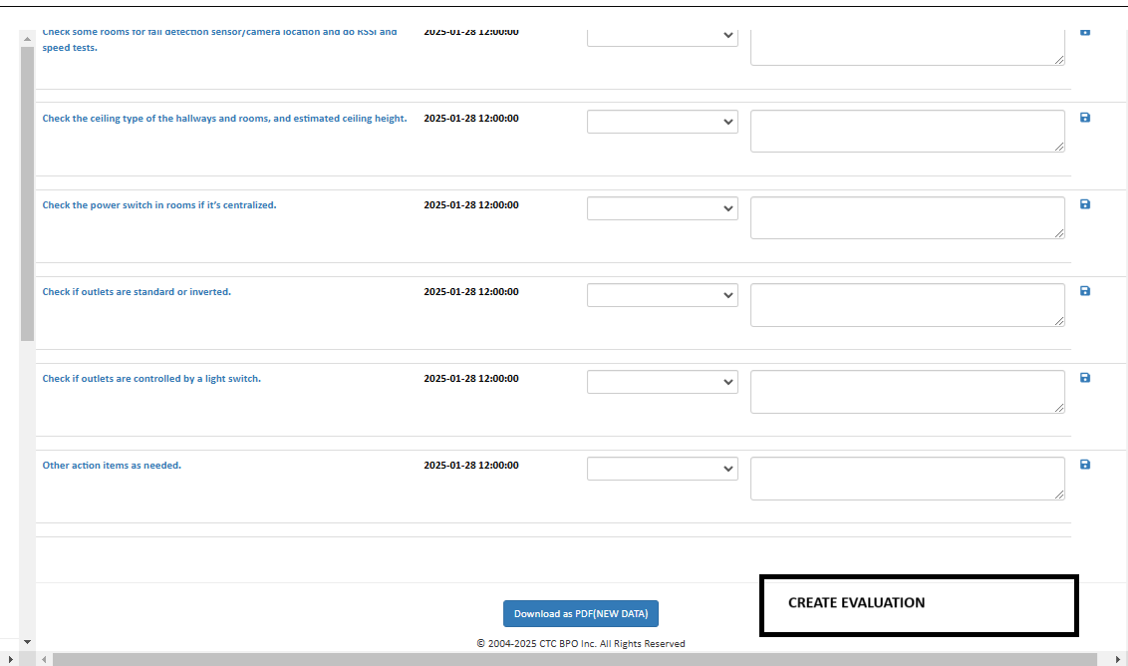  - See attached evaluation forms.  - Add the quality scores to the Work Order Report
Fix implemented
Regression Test Performed
Side effects of Fix
Solution Acceptor Comments

