CallTek Engineering Request

System Type | Airtower Splash Page Request | Name of Requester | Justin
Request Date | January 31, 2025 | Name of Engineer
Revision Date |  | Approved by
Version No. |  | Approval Date

TASKS
Identified Issue or Feature Request | *Account: Airtower  *Property Name: One Rangers Way  *The client requested a custom splash page to be used for the entire property  - this site uses an RXG gateway and the client wants to have this portal page design with the following specifications.  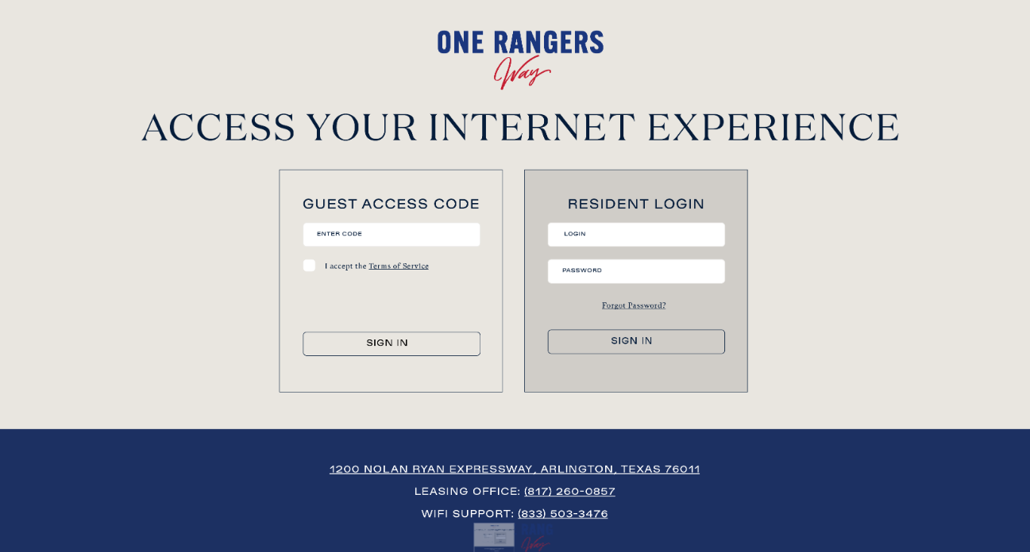  Fonts & Colors:  - Large Header Font: Domaine Display (#051C3A)  - Login Sections Font: Gubestile Medium (#051C3A)  - Forgot Password / I Accept Terms of Service Font: GT Super Text Book (#051C3A)  - Footer Text Font: Gubestile Medium (#FFFFFF)  - Button Text Font: Gubestile Medium (#051C3A)  Page Elements:  - Footer Box Color: #1C3062  - Page Background Color: #E9E6E0  - Button Color: #E9E6E0  - Hover Color: #D0CDC8  - Outline Color: #051C3A  RXG url: https://onerangersway.netlogin.app/admin/  (let me know who will work on this and I will share my credentials)  - The property logo is attached on this email  - The current splash page file of the property is also attached on this email
Goal | * Custom Portal Request for One Rangers Way (Airtower Client)

