CallTek Engineering Request
System Type | QIS Assessments/Call Reviews | Name of Requester | Gwen
Request Date | Feb. 11, 2025 | Name of Engineer | IT DEV
Approved by |  | Approval Date

Task
Identified Issue or Feature request | - To include "Agents Name" and "Ticket Number" in the subject line of emails sent to supervisors regarding assessments and coach back notifications.  Example:  Instead of below:  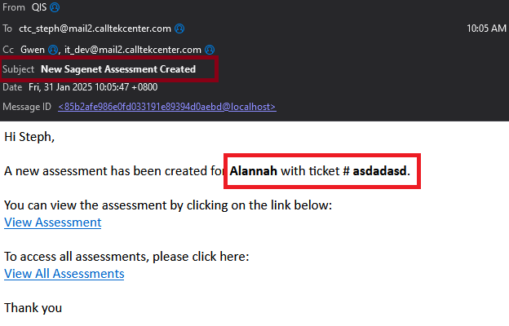  Email subject should be:  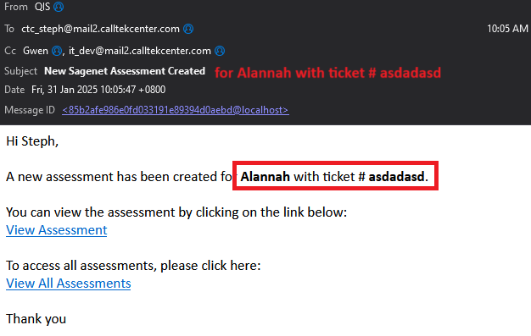
Goal | For SageNet Leadership to be notified for any QIS assessments.
Root Cause and Findings
Fix implemented
Regression Test Performed
Side effects of Fix
Solution Acceptor Comments

