CallTek Engineering Request
System Type | CAS – | Name of Requester | Joei
Request Date | Feb 11, 2025 | Name of Engineer | IT DEV
Approved by | OMS | Approval Date

Task
Identified Issue or Feature request | Integrate work order and work order task cases to CAS for all WV – team (WIFI, MDU, Video)  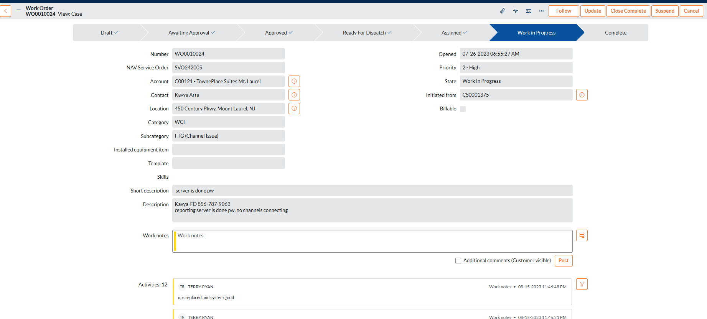  - Create Work Order Form (including all data fields needed) - Use the sample Snow WO form as reference. (see image below)  As for the Billable option, we should use dropdown selection instead of check box. This is a request from the client, they have a checkbox option currently set up for this in snow, once we have it in CAS then they will create the corresponding selection in snow to match what we have.  Drop down selection are:  Billable  Non-Billable  Exception -non-billable  - Create a work order TASK form: We should also include all the fields shown in Work order Task form, see sample from SNOW:  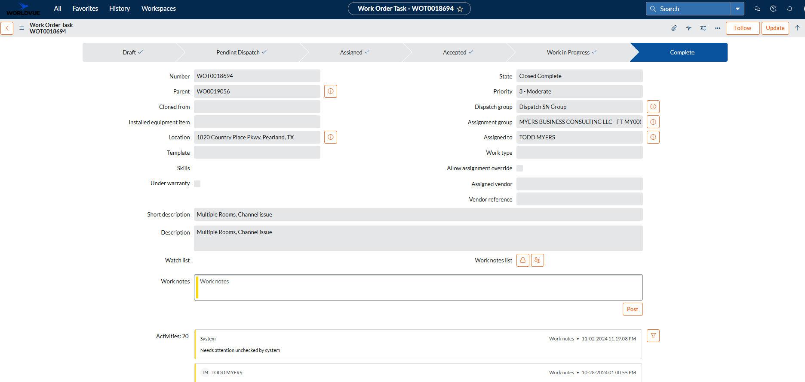  - Work Order Form should be added to the case, where the WO is linked. Create a Tab within the case to view the WO (sample image from CAS)  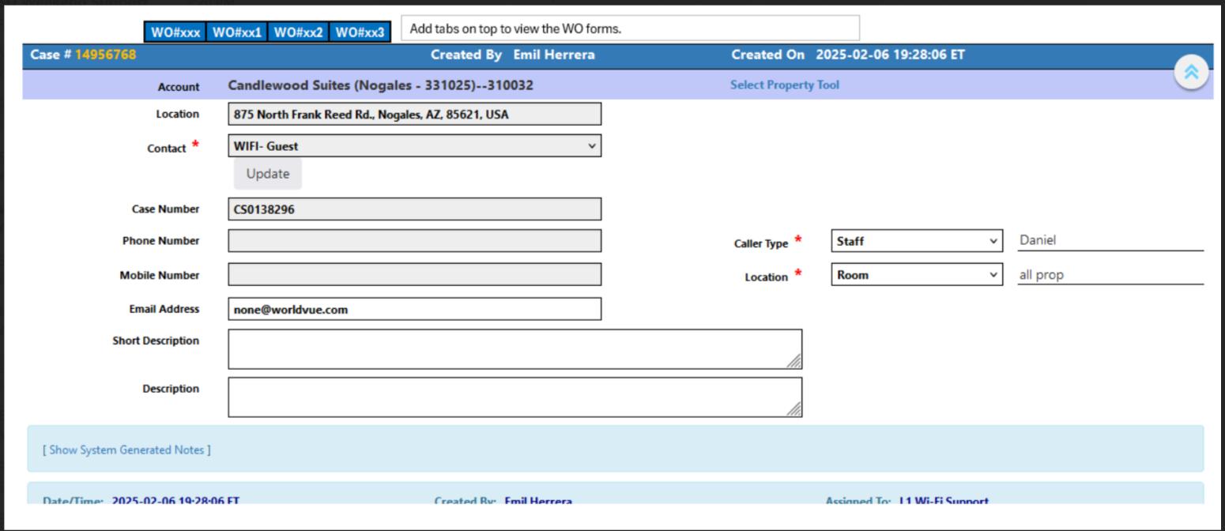  - Work order number / work order task number – should also be searchable via main function search tool in CAS.  - Create a link report in cas that will allow users to easily see all the work order reports detail as shown below:  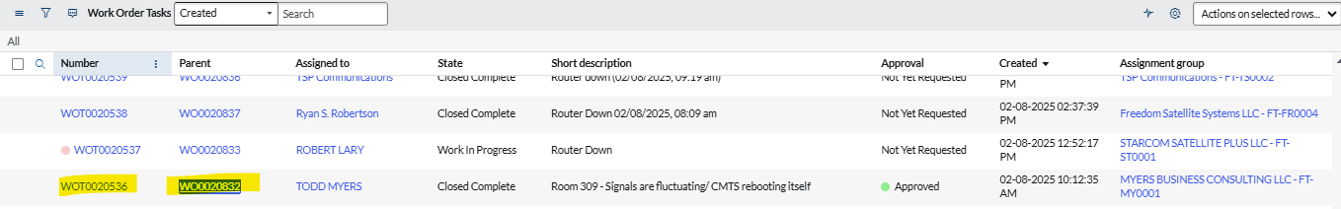  - Once 1, 2, 3 is created, mapped the Fields from Service Now Work Order Form to CAS Work Order Form/ Work Oder Tasks form.  **We need to also check/research if we can fetch the WO data from SNOW via API before the CAS fields can be populated  ** Example of SNOW tickets with linked WO numbers.  Sample snow case that exists in CAS:  CS0138780, with WO link to it  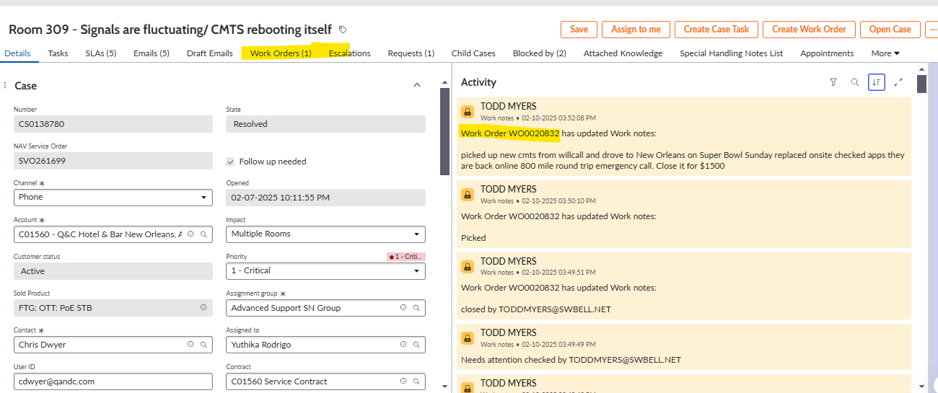  View case & click work order – you also see the number from here.  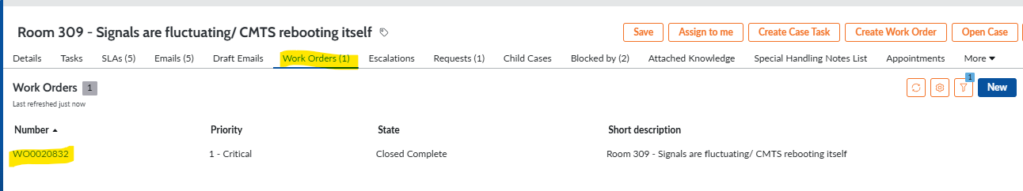  After clicking work order it shows the work order notes: (like what’s shown in the CS case)  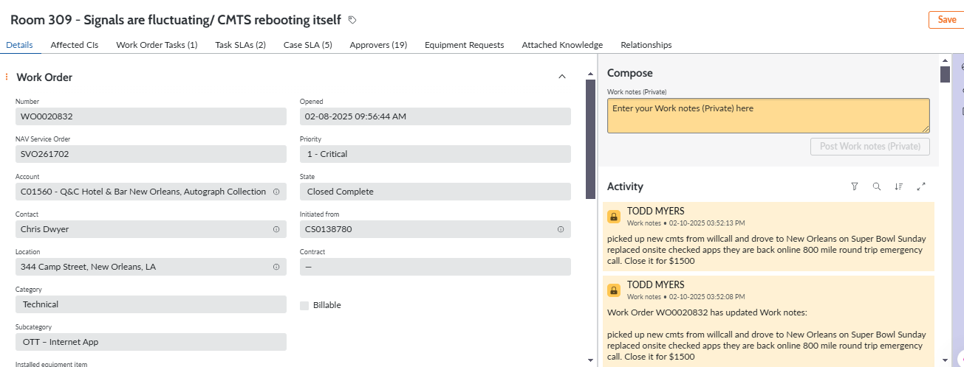  CAS – Case equivalent:  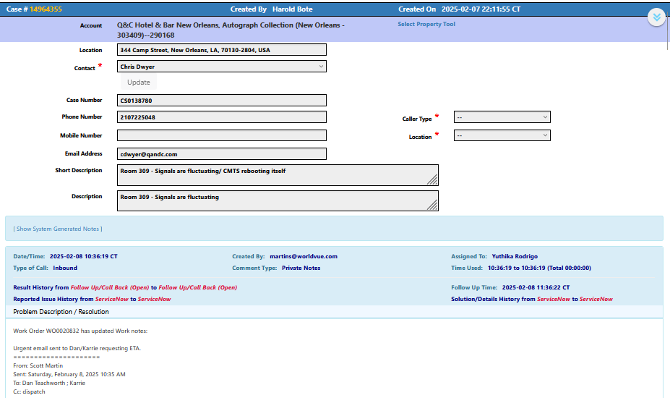
Goal | Truck roll / Field tech requests visibility in CAS
Root Cause and Findings
Fix implemented
Regression Test Performed
Side effects of Fix
Solution Acceptor Comments

