CallTek Engineering Request

System Type | CAS to Salesforce Integration | Name of Requester | Justin
Request Date | February 11, 2025 | Name of Engineer
Revision Date |  | Approved by
Version No. |  | Approval Date

TASKS
Identified Issue or Feature Request | *Account: Altice  *Salesforce Sandbox:  https://alticeusamdu--calltek.sandbox.my.salesforce.com/  username: calltek@mdu.com.calltek  pw: Managedwifi2025  *Integrate CAS to Salesforce  See the attached Excel file for the mapping and values of each field.  *Our goal is to allow calltek agents to create a ticket in CAS that will push to Salesforce. Tickets in salesforce should be a “Read-only” ticket except for these three which can be updated or changed from the client’s end. Client will not be creating a ticket to push backwards to calltek.  1.Problem Descripton (client will update their notes and will be pushed to CAS)  2.Result (Status )  2.Solution  *Add a Customer Verification Logic (same logic as ATT’s CAS as per Tony’s instructions and client agreed)  -agents will get the phone number of the account holder from the RXG, paste it into the registered phone number field and will send an one time pin to the number. The customer will provide it over the phone and verify. Once the customer is verified, agent will get the regular CAS ticket form for ticket creation  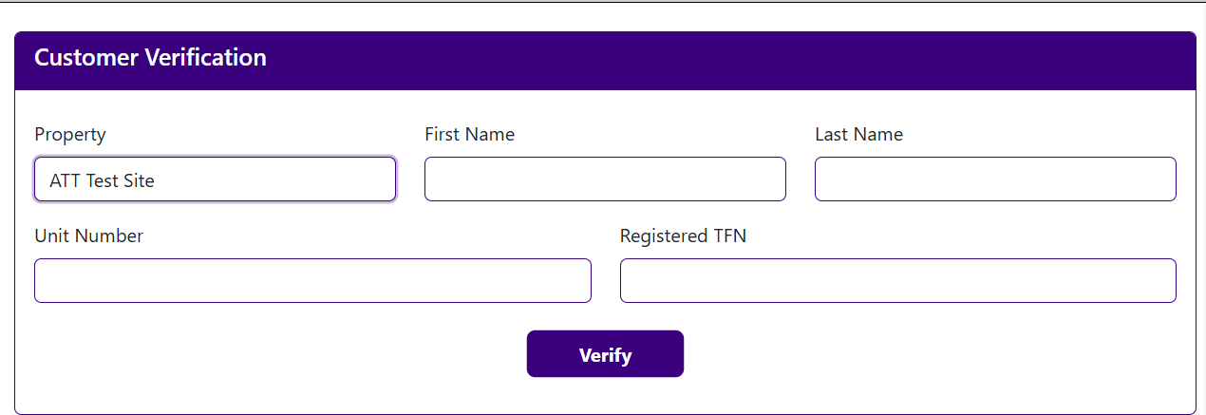  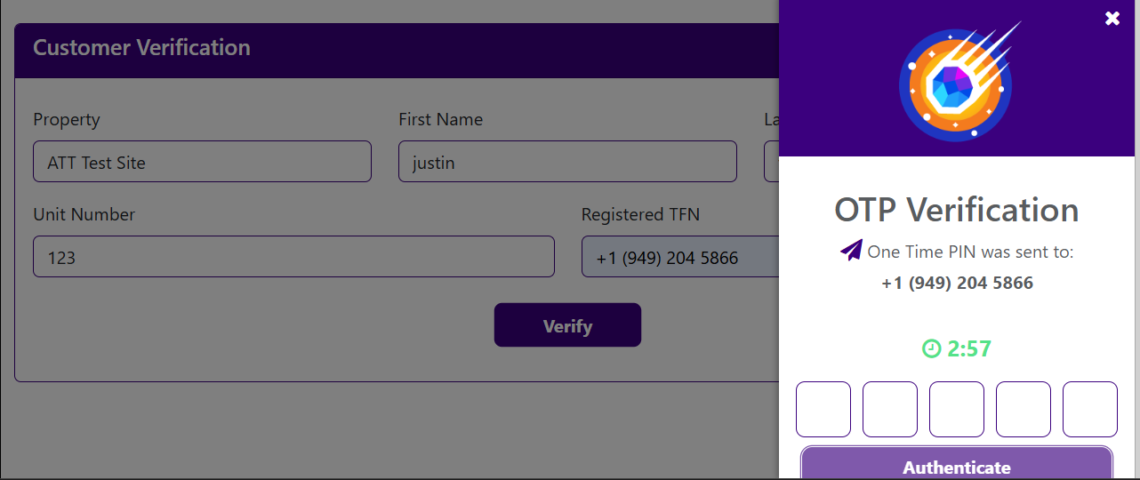  OTP verification will stay the same (3 minutes)  A Test property Should also be created as a placeholder for calls that are unverified (ghost calls, not the account holder, etc) and should also automatically create a ticket in CAS and salesforce for this kind of call.
Goal | - Integrate Salesforce to CAS

