CallTek Engineering Request

System Type | ATT Engineering Request | Name of Requester | Justin
Request Date | February 3, 2025 | Name of Engineer
Revision Date |  | Approved by
Version No. |  | Approval Date

TASKS
Identified Issue or Feature Request | *Account: ATT  * provide an API to be used by ATT for tech dispatch (Calltek-API-1)  Dispatch Request Flow:  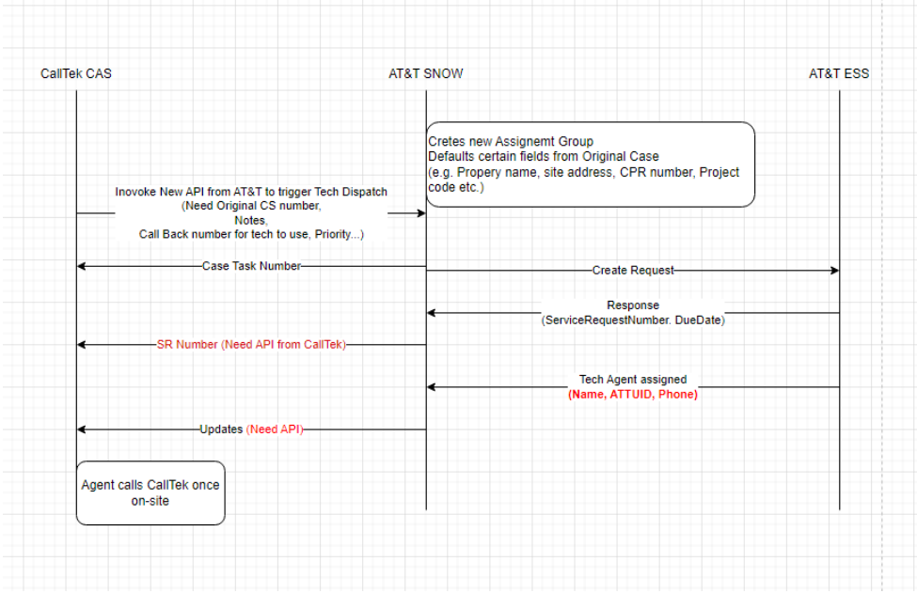  - Calltek NOC will initially request an onsite tech dispatch containing  ATT Pending Item #1: to provide an API endpoint to request for a tech dispatch  - Calltek NOC will request the status of the dispatch request and tech details.  ATT pending Item #2: to provide an API endpoint where they can provide the status of the tech dispatch  - Calltek NOC will close or cancel the tech dispatch  ATT pending item #3: to provide an API endpoint to close and cancel the dispatch  CallTek-API-1: For A&T to provide Service request number, Tech details, any updates from ESS to CallTek. Calltek will provide a CAS API to ATT for them to update tech status and tech dispatch details.
Input:
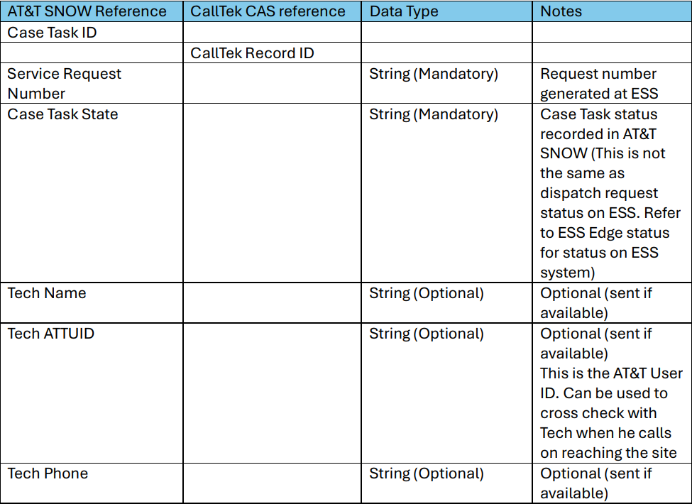
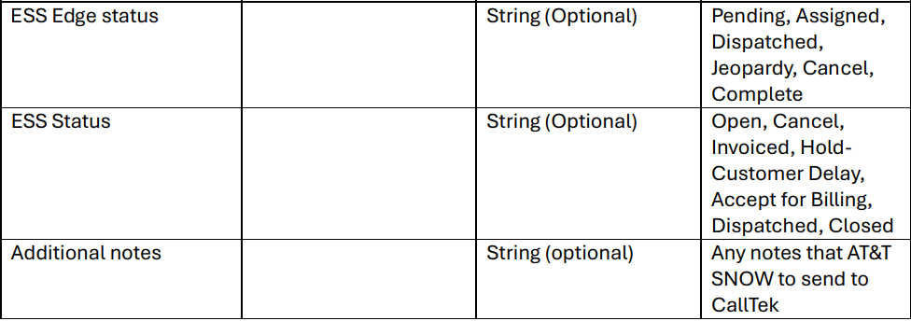

Goal | * provide an API to be used by ATT for tech dispatch

