CallTek Engineering Request
System Type | CAS | Name of Requester | Joei
Request Date | February 2, 2025 | Name of Engineer | IT DEV
Approved by | OMS | Approval Date

Task
Identified Issue or Feature request | Need to map the new fields in CAS to Service now.  Field names:  Caller Type : Guest, Resident, Staff and its description.s  Location: Room, Unit # , Common area and its description.
Goal | Map the new fields for case reporting purposes in Service now.
Root Cause and Findings | Sample CAS UI :  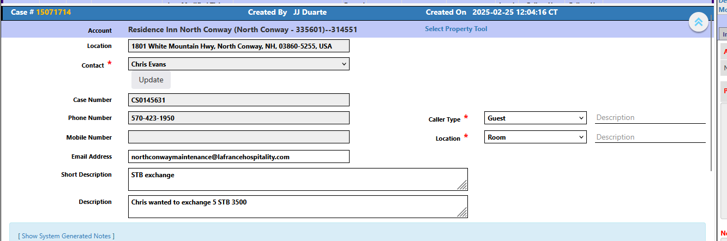  Service now UI:  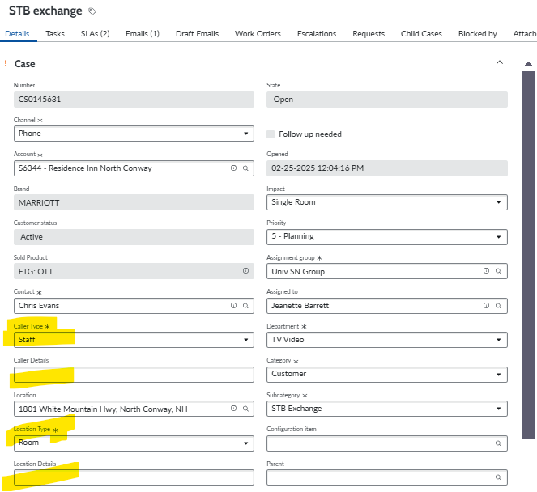
  CAS | Service Now
  Caller Type:  Guest  Resident  Staff | Caller Type:  Guest  Resident  Staff
  Description | Caller details
  Location:  Room  Unit #  Common area | Location Type:  Room  Unit number  Common Area
  Description | Location Details
Fix implemented
Regression Test Performed
Side effects of Fix
Solution Acceptor Comments

