CTC BPO Inc. Engineering Request
System Type | Green Octopus | Name of Requester | Cathleen
Request Date | 3/9/2025 | Name of Engineer | Karl/Franz
Approved by |  | Estimated Completion
Approval Date

Task | Green Octopus Enhancement
Identified Issue or Feature request | - Arrange the Vendor List in the Superadmin account in alphabetical order.  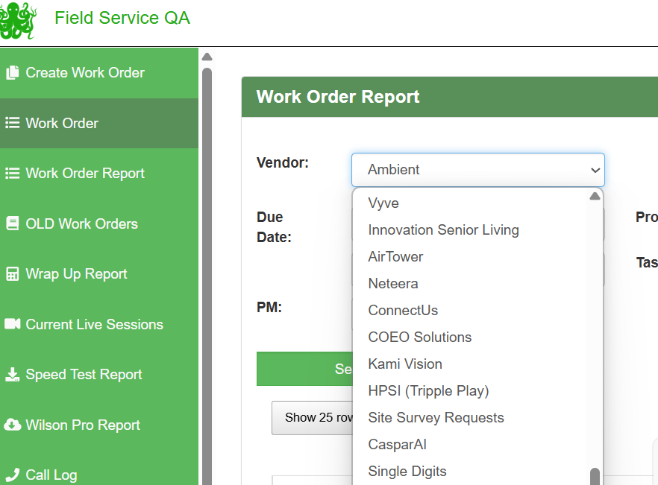  - Add a summary of the score per category in the QA Form -  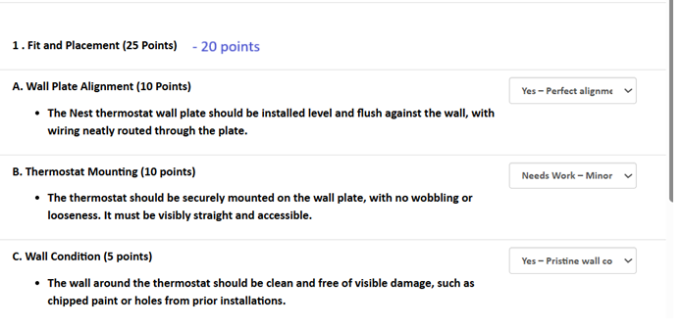  QPE Sample:  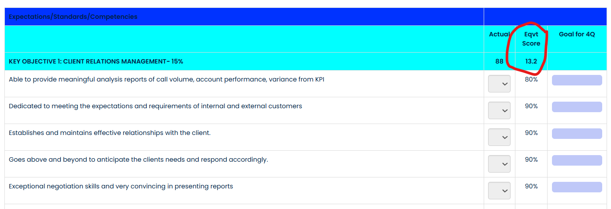
Fix implemented
Regression Test Performed
Side effects of Fix
Solution Acceptor Comments

