CallTek Engineering Request
System Type | CAS – SF integration | Name of Requester | Selma/Tina
Request Date | March 16, 2025 | Name of Engineer | IT DEV
Approved by |  | Approval Date

Task
Enable CAS Option Call Type. This should be a required field. | 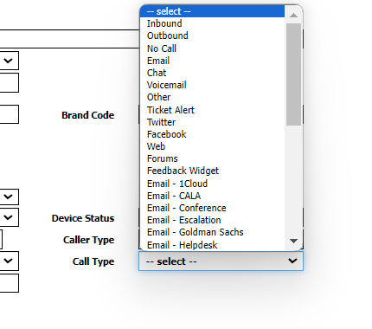
Goal | To be able to log inbound / outbound calls in CAS which will help Datamining team get the calls and match it to its case.  The options should only be the following:  Type of call:  - Inbound  - Outbound  - Email  - Chat
Root Cause and Findings
Fix implemented
Regression Test Performed
Side effects of Fix
Solution Acceptor Comments

