CallTek Engineering Request
System Type | CAS – SF integration | Name of Requester | Selma/Tina
Request Date | March 16, 2025 | Name of Engineer | IT DEV
Approved by |  | Approval Date

Task
Create a Tick box labeled as Handshake to indicate a case will be escalated to Call Center Tier2. Make this a required field if: Status In progress and Assigned Queue: Call Center Tier 2. | 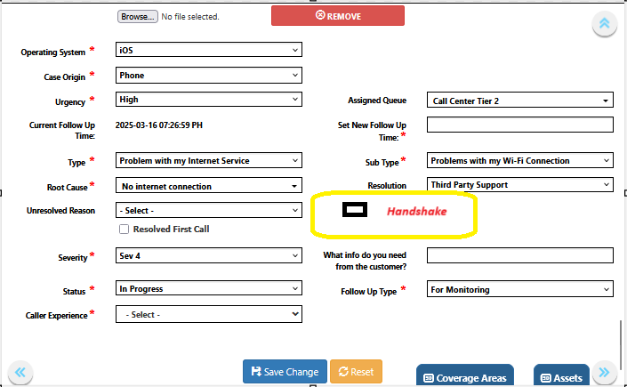
Goal | To help Tier 1s adhere to the SD escalation process and for reporting purposes.
Root Cause and Findings
Fix implemented
Regression Test Performed
Side effects of Fix
Solution Acceptor Comments

