CallTek Engineering Request
System Type | TRKD, Doctor’s Dashboard | Name of Requester | Vern
Request Date | 2/21/2025 | Name of Engineer | IT Development
Approved by |  | Approval Date

Task | TRKD, Doctors Dashboard
Identified Issue or Feature request | - Provide option under Security Audit Listing Report to set a specific date range to check  - Once the data range option is available, we can just list the ideal credentials who attempted to access the Dashboard within the set dates and add two columns to indicate the number of attempts made – Successful and Unsuccessful.
Details | - When generating the report for Security Audit Listing, an option to select a specific date range to check would be very helpful to narrow down the results  Current View  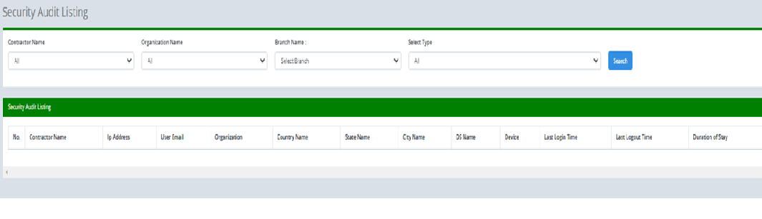  Proposed  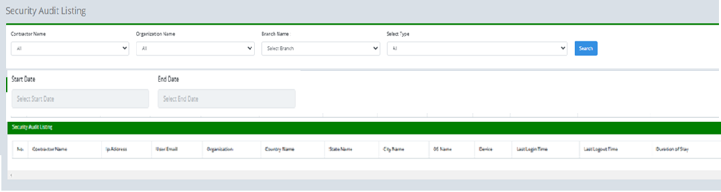  - The last 2 columns should indicate the total number of attempts made both successful and unsuccessful within the set date range.  