CallTek Engineering Request

System Type | Airtower Landing Page Customization | Name of Requester | Justin
Request Date | February 24, 2025 | Name of Engineer
Revision Date |  | Approved by
Version No. |  | Approval Date

TASKS
Identified Issue or Feature Request | *Account: Airtower  *Property Name: One Rangers Way  *The client requested a customize their landing page  1. Header "Access Your Internet Experience" must be in the center  2. Remove/Hide "Generate API Key" label  3. Use the same font on the splash page  4. Change Background image to the one attached  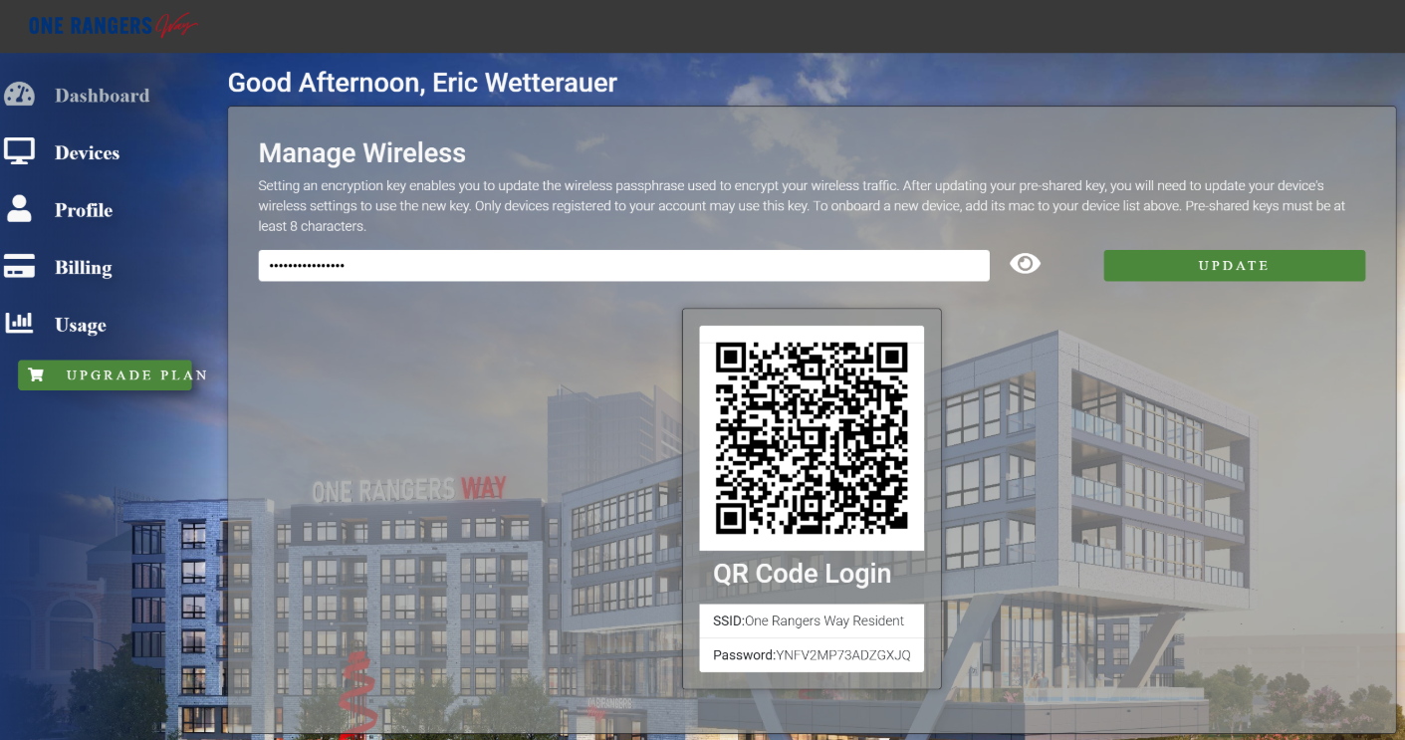  RXG url: https://onerangersway.netlogin.app/admin/  (let me know who will work on this and I will share my credentials)  RXG sandbox: https://rxglab2.cosmos.us.com/admin  - The property background image is attached to this email
Goal | * Customize Landing Page for One Rangers Way (Airtower Client)

