CallTek Engineering Request
System Type | Green Octopus (All Vendors) | Name of Requester | Bless
Request Date | April 9, 2025 | Name of Engineer
Approved by |  | Estimated Completion
Approval Date

Task
Identified Issue or Feature request | - Disable browser notifications whenever changes are made on the platform.  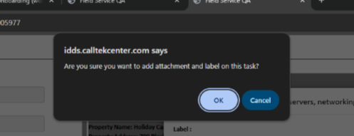  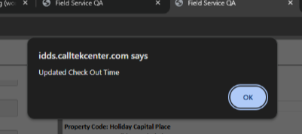  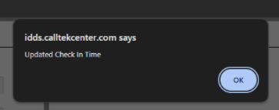  - Allow multiple entries for Check-in/out Time in cases of revisits or multi-day dispatch. And then compute for the total duration based on the overall time spent on-site.  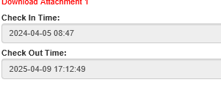  Sample:  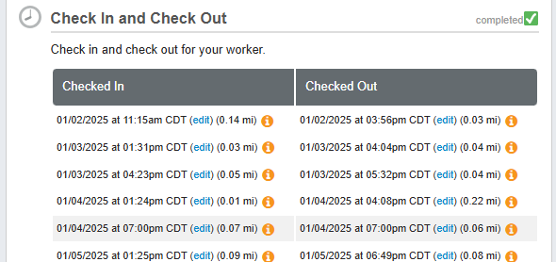  - Option to remove photos uploaded by mistake in the Tasklist window.  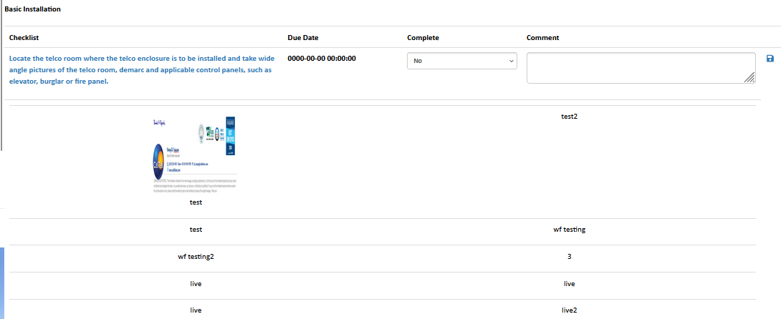  - Disable automatic updates in the Check-in/Check-out Time fields. Currently, the fields update each time they are clicked, even if no changes are made.  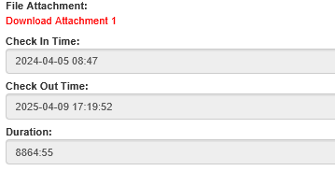  - Enable the search bar to display results regardless of the date range set in the Due Date field.  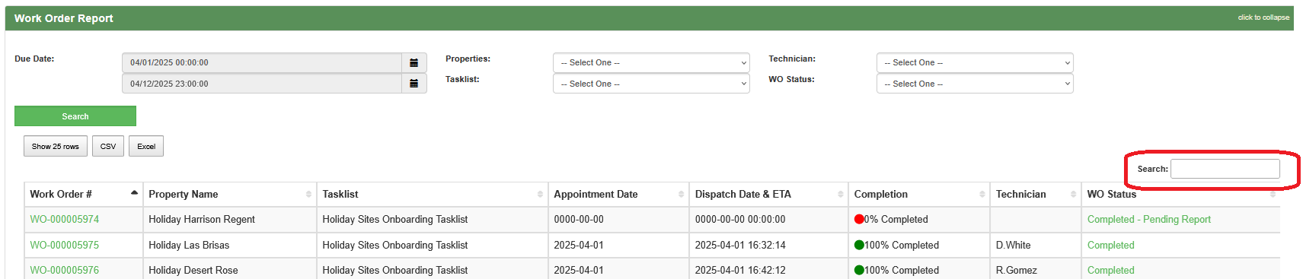  - In the Work Order Dashboard, replace the 'Username' with the 'Technician Name' in the 'Technician' column.  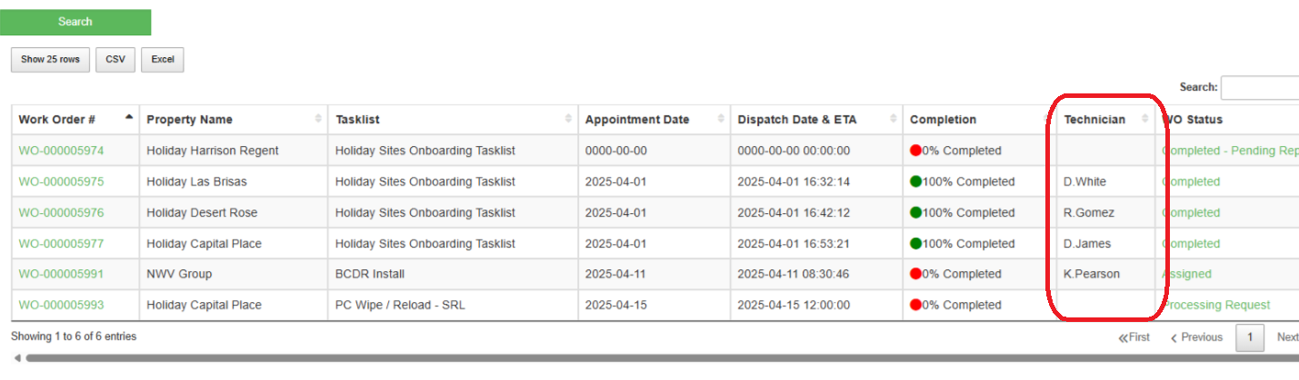
Goal | - Efficiently use the platform.
Root Cause and Findings | NA
Fix implemented | NA
Regression Test Performed | NA
Side effects of Fix | NA
Solution Acceptor Comments | NA

