CallTek Engineering Request
System Type | CAS | Name of Requester | Alexis
Request Date | June 14, 2024 | Name of Engineer
Approved by |  | Approval Date

Task
Identified Issue or Feature request | - Auto-Response Email Template  - Update the auto-response templates and send auto-response on certain scenarios  - Email Signature Update  - The signature used in our current email-to-ticket system contains outdated. At present, the team manually updates this signature with each email sent.  - Post Event Survey  - Incorporating a survey into the ticket closure notification.  - Note Types Filter  - Enabling a feature that allows the selection of note types within a ticket. This enhancement could provide more flexibility and precision in ticket management.  - Support Numbers Update and First Notification Auto Response Update  - Update the auto-response system to include the dedicated support numbers that are specific to each brand.  - Remove the phrase “Rest assured” in the first notification’s auto response  - Intercepting Auto Responses for Automated Emails  - Our SNA customers also operate with an automated system for ticket creation, incident reports, notifications, etc. With our current "email to CAS" system, the team is constantly dealing with "bot war," wherein CAS and our customer's automated system trigger auto-responses for these types of emails, creating duplicate tickets and spam emails.  - Bulk Ticket Deletion and Closure  - With the ongoing issues on loop, duplicate and spam emails, there is a need to have the option to delete or close tickets in bulk as this is being done one by one currently and is very time consuming.  - Auto-Response Recipients  - Only the sender- who made a follow up to the existing email should receive the auto response acknowledgement email.  - Email to Ticket Metrics  - Our client requested to see the data on email to tickets for analysis  - Auto Response Template Manual Triggers  - To add Auto-Response Template as a ticket field and add radio buttons for its options in order to trigger email auto-response templates  - Opt Out Ticket Closed Notification  - For CAS/system not to send the “Ticket has been Closed” notification for unresolved tickets. This is applicable when closing duplicate tickets or an existing ticket being closed as it’s appended to a parent ticket.  - Ticket Note Types Selection  - Enabling a feature that allows the selection of note types within a ticket. This enhancement could provide more flexibility and precision in ticket management.
Goal | - To ensure that emails are acknowledged and responded timely  - To guarantee that the signature used in the email-to-ticket system accurately reflects the most current information for SNA. This update will also help with the team’s efficiency as it eliminates a manual process.  - Evaluate our effectiveness in resolving tickets, as measured by customer satisfaction and customer experience, directly from the customers’ perspective, which will help improve our overall customer experience.  - To be more efficient in tracking case notes history by using targeted review of ticket logs using the type of notes. This could aid in easily understanding the overall scenario and status of a case.  - To ensure that customers are directed to the most appropriate support numbers enhancing their experience and improving efficiency. This approach will also enable our support team to identify the brand associated with the incoming call even before answering it. Furthermore, it will enhance the precision of our PBX reporting.  To address our client’s request, we will remove the phrase “Rest Assured” from the first notification. This change is aimed at setting accurate expectations for our customers.  - Dev team has currently created a feature in CAS where we can "whitelist" the email addresses of these automated email senders to intercept the auto-responses, which is helping the team fix the bot war. However, we recently determined that we are not just intercepting the auto-responses when we whitelist these email addresses; we are also eliminating the ability of our agents to send outgoing emails to these recipients, which is not going to work for the team. With this in mind, we would like to request another system or feature that can also filter keywords from an email subject, content and contact’s display name to intercept the auto-responses.  - To be efficient in the process of closing tickets for duplicate/loop emails.  - To limit the auto-response received by the email addresses that are carbon-copied in the email  - To see the email to tickets data  - To ensure standard and professional responses are being sent to our customers  - Opting out the auto response when closing unresolved tickets such as for duplicate tickets will ensure that we’re not sending the wrong messaging to our customers that their issue is resolved.  - To be more efficient in tracking case notes history by using targeted review of ticket logs using the type of notes. This could aid in easily understanding the overall scenario and status of a case.
Root Cause and Findings | - Please refer to the file “Auto-Response Template V6” for the templates and scenarios  - Email Signature Update  - Current email signature  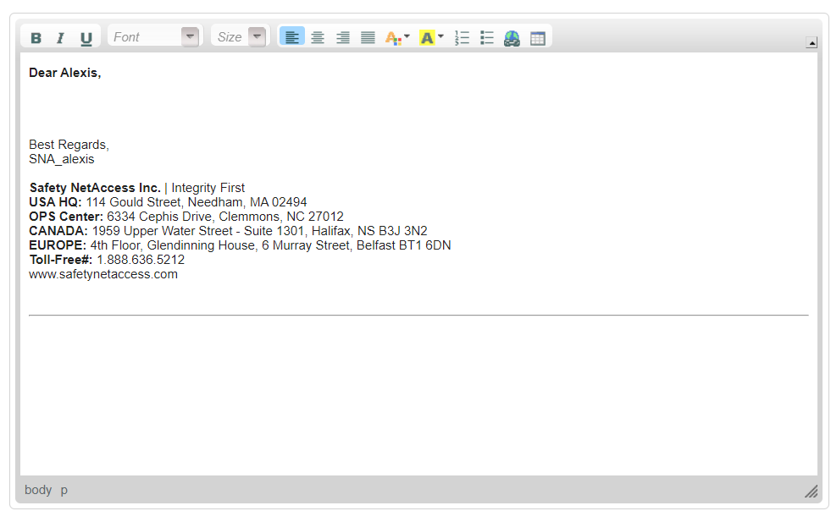  - Updated email signature  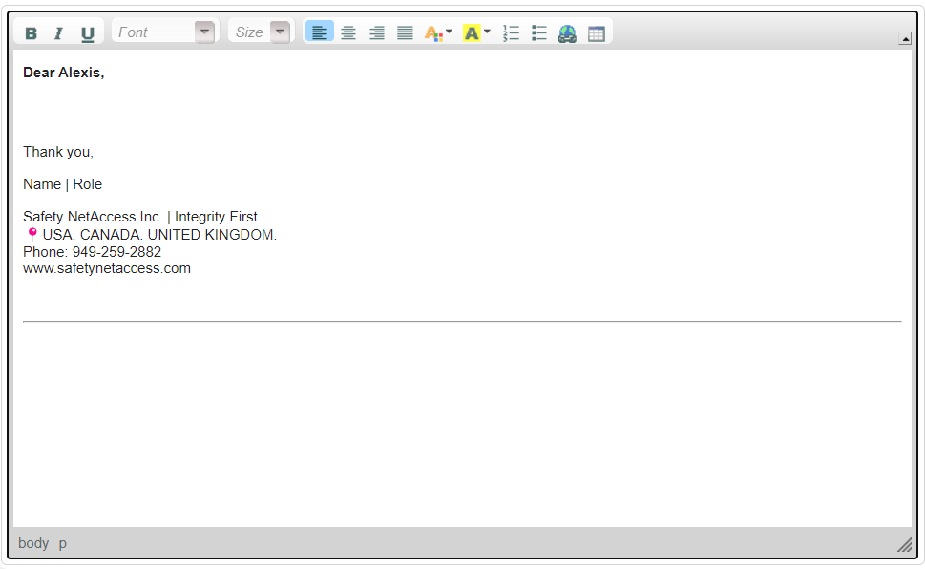  - The role will be updated manually (for now).  - Post Event Survey  - The automated response for ticket closure will now incorporate a message regarding the post survey (2-scale survey). Below is the updated template:  Hello [Customer Name],  We are pleased to inform you that your issue, with reference # 123456, has been successfully resolved and the corresponding ticket has been closed.  Your feedback is important to us. We invite you to share your experience with our customer service by clicking on one of the links below:  I’m Satisfied.  I’m Unsatisfied  Should you require immediate assistance, feel free to contact us at the following support numbers:  - Support Phone # 1  - Support Phone #2 if applicable  - Support Phone #3 if applicable  Our Helpdesk is committed to serving you 24 X 7 X 365.  Thank you once again for contacting Safety NetAccess. It was our pleasure assisting you.  - After clicking one of the links, it will direct to a new tab/window which will prompt the customer to leave their feedback/comments.  We appreciate your feedback. We greatly value your insights and experiences. Please share your comments about your recent interaction with us. Your input helps us continually improve and serve you better.  NOT NOW  SUBMIT  - Upon the customer’s submission (sharing feedback and hitting ‘Submit’), a pop-up window will appear, expressing our gratitude for their participation in the survey and sharing their feedback and/or comments.  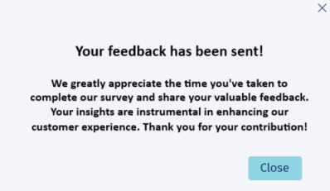  - Alternatively, if the customer chooses to click on ‘Not Now’, a pop-up window will appear, conveying our appreciation for their participation in the survey.  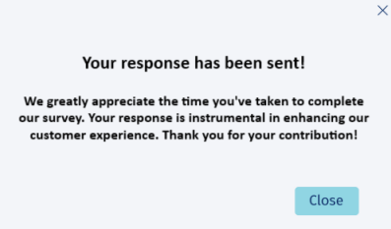  - For the database and reporting, include an option named ‘Survey Results’ under the ‘Reports’ section in CAS.  - The report page should display the following search filters: ‘Ticket Date’ (with a range option), ‘Survey Result’ (with options for ‘All’, ‘Satisfied’, and ‘Unsatisfied’), ‘Vendor’, ‘Chain/Brand’ and ‘Comments’.  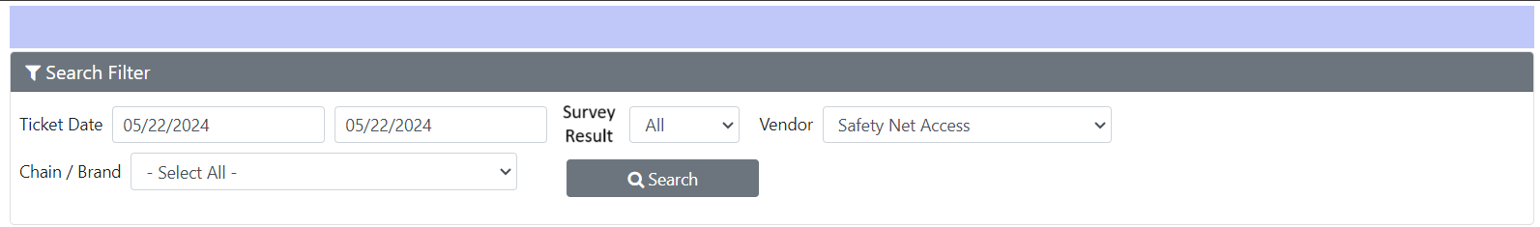  - For the ticket queries in the search results, the layout can remain identical to the one in the provided screenshot, with the addition of a ‘Result’ column at the end.  - A feature to export the survey results in Excel format should be available for data analysis and accessibility.  - Note Types Filter  - In reference to the sample ticket 13456061, the ticket includes notes from various sources such as outbound calls and emails sent to the site. To enhance our ticketing system, we propose the addition of a ‘Note Type’ field in the ticket form. This field would offer options like ‘All’, ‘Internal Note’, and ‘Email Notification’. Selecting ‘Internal Note’ would display all internal notes, ‘Email Notification’ would show only email communications, and ‘All’ would display all types of notes.  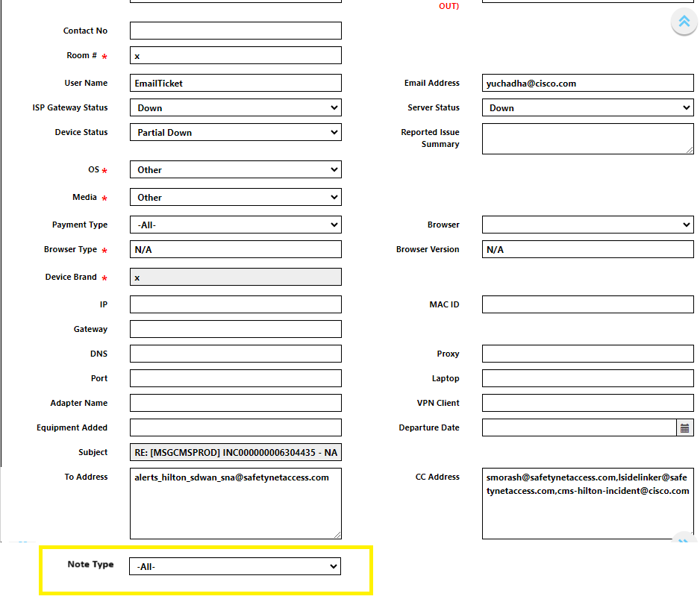  - Support Numbers Update and First Notification Auto Response Update  Kindly refer to the separate attachments of the updated Auto Response templates and the Support Numbers document.  - Intercepting Auto Responses for Automated Emails  Below are some of the keywords from an email subject and email content that we need to filter without the auto-responses being triggered but still with a ticket generated in CAS.  We will have a few more of these, and once this feature gets approved and implemented, we would love to have the access or ability to do this so we can just immediately make the change if we come across any bot war situation or spam emails.  Email subject incudes:  - IT Service Desk Ticketing  - Request with ID  - New request created with ID  - Your request has been logged with request id  - Daily Equipment Report  - Equipment Status Report  - SNA- Issue reported  - [Enseo Customer Support Request Received]  Message Body includes:  - Your request has been updated. To add additional comments, reply to this email.  - Thank you for contacting the Actabl BI & Labor support department. Your request has been assigned  - The following ticket has been closed. If you feel this issue has not been resolved please open a new ticket and reference ticket number in the new ticket.  - Bulk Ticket Deletion and Closure  - Add an option under System Settings to have this feature.  - The option may be inserted after “Manage Ticket Settings” and we may name the option “Manage Email Tickets”  - For the options inside this functionality, we just need to have the option to paste multiple ticket numbers (perhaps inside a box) and a button to delete and a button to close. We also need to add an option for case notes which will be applicable for all tickets included in the box after hitting the close button.  - Auto-Response Recipients  - First email – auto REPLY TO ALL  - All emails in between or subsequent emails - only to the main recipient; email address/es in the "To" field  - Last email/closed notification - REPLY TO ALL  - Email to Tickets Metrics  - Client requested to add tabs in the Daily Ops Report for the Email to Tickets Data.  Tab name: Email to Tickets Data  - # of emails converted to tickets  - # of closed tickets from emails  - # of responded tickets  - Resolution time SLA – based on response time metrics  - Response time SLA – based on response time metrics  - Follow up time SLA – based on follow up time metrics  - To add a drop down filter menu in Resolution Time Report, Response time Report and Follow up Time Report for Tickets.  - All Tickets – should show all tickets in CAS  - Tickets from Email – should show all tickets from Email in CAS  Something like this:  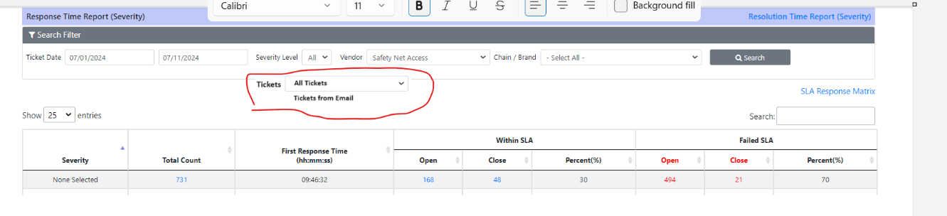  - To add a column in the Brand Tab (Hilton, Marriott, OMNI, Sonesta, Hyatt, Choice, BestWestern) and in the Summary Tab per Brand to add the following data.  - # of emails converted to tickets  - # of closed tickets from emails  - # of responded tickets  - Resolution time SLA – based on response time metrics  - Response time SLA – based on response time metrics  - Follow up time SLA – based on follow up time metrics  - Auto-Response Manual Triggers  - Add Auto-Response Template as a field below Follow-up Type  Add 4 radio buttons for the following selections: 1st Attempt, 2nd Attempt, 3rd Attempt and Escalation  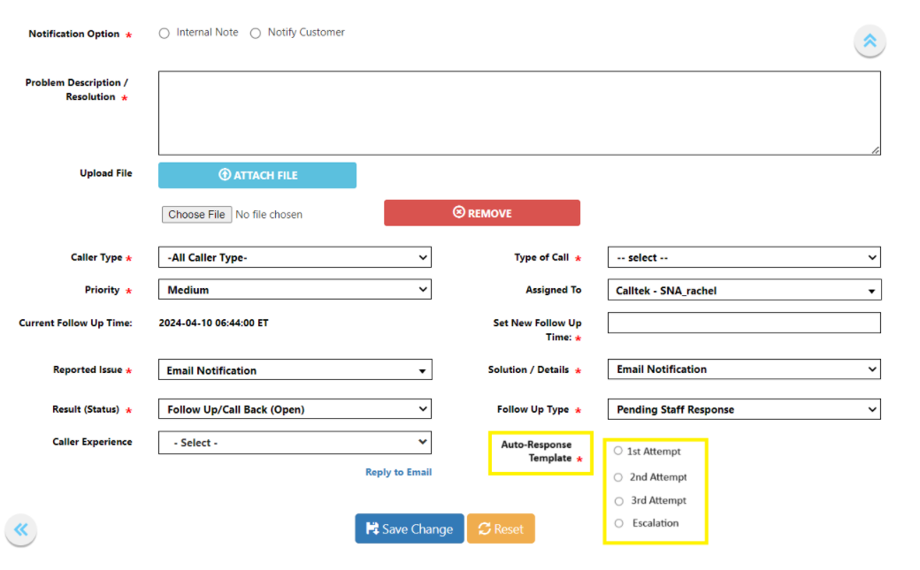  Hitting Save Change will send the corresponding response based on the corresponding template (see attached word file)  - Opt Out Ticket Closed Notification  - When selecting “Closed” as the ticket Result (Status), a radio button should appear to opt out the ticket closed auto-response.    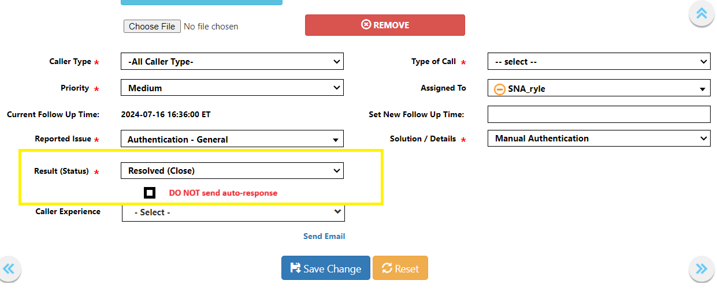  - Ticket Note Types Selection  - In reference to the sample ticket 13456061, the ticket includes notes from various sources such as outbound calls and emails sent to the site. To enhance our ticketing system, we propose the addition of a ‘Note Type’ field in the ticket form. This field would offer options like ‘All’, ‘Internal Note’, and ‘Email Notification’. Selecting ‘Internal Note’ would display all internal notes, ‘Email Notification’ would show only email communications, and ‘All’ would display all types of notes.
Fix implemented
Regression Test Performed
Side effects of Fix
Solution Acceptor Comments

