CallTek Engineering Request
System Type | QIS | Name of Requester | Gwen
Request Date | Sept. 5, 2024 | Name of Engineer | IT DEV
Approved by |  | Approval Date

Task
Identified Issue or Feature request | SageNet is requesting that its Coach Back (CoBa) form be made accessible in QIS. SageNet uses CoBa as a tracking tool for coaching opportunities for CallTek and the US Team.  For further information, see the section below.
Goal | To make use of QIS for coaching opportunities and call assessments.
Root Cause and Findings
Fix implemented
Regression Test Performed
Side effects of Fix
Solution Acceptor Comments

( CoBa ) Coach Back in QIS
- An option for COACH BACK >> Create Coach Back will be under Tools tab.
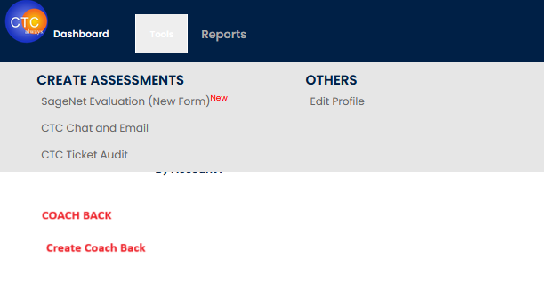

- After clicking on “Create Coach Back” link, it will open a new tab or window with the following options:
Date
Associate
Case Number
Customer
Brief Summary of the CoBa
Detail of CoBa, if necessary

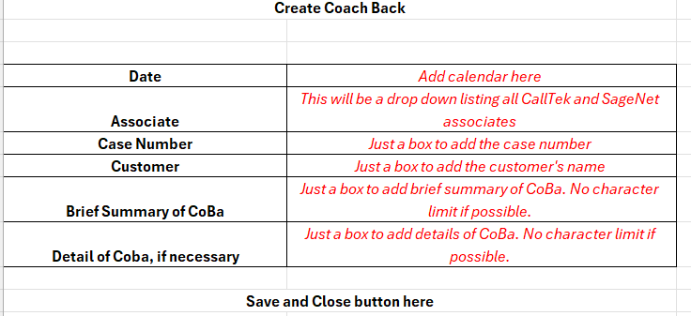
Example:
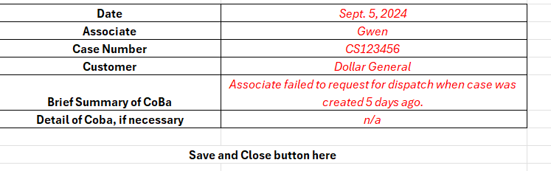

- Under the Reports tab, new options will be added. VIEW COACH BACK REPORT >> View Coach Back Report.
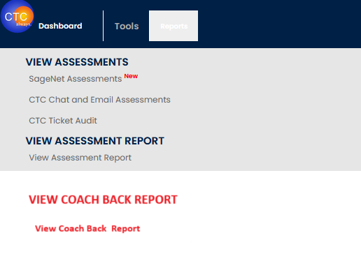
"View Coach Back Report" will display all the Coach Backs that have been contributed by all leaders, along with a hammer icon that indicates the need for coaching on the left side of each CoBa.
It will look like this: 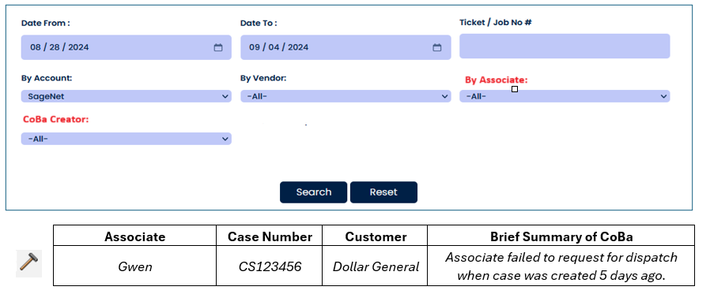

By Account and By Vendor – please make sure SageNet is the only option.
By Associate – All CallTek and SageNet associate
CoBa Creator – All leaders both CallTek and SageNet’s side.
After clicking on the icon, it will open a new tab or window where the Associates Supervisor can add his/her Coaching Remarks ( red ) .
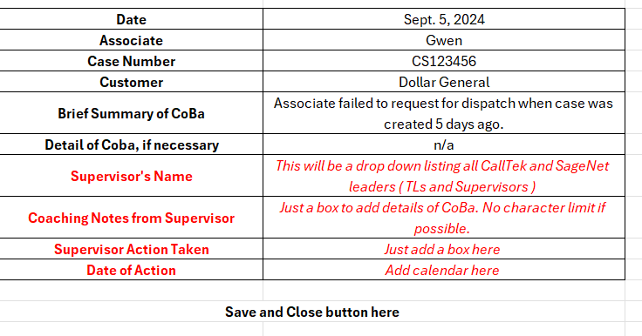

After saving, the icon will disappear from “View Coach Back Report” link indicating that coaching and remarks were completed.

To view the Supervisor’s Remarks, a “View Report” or “View Coaching Report” option should be added at the right side.
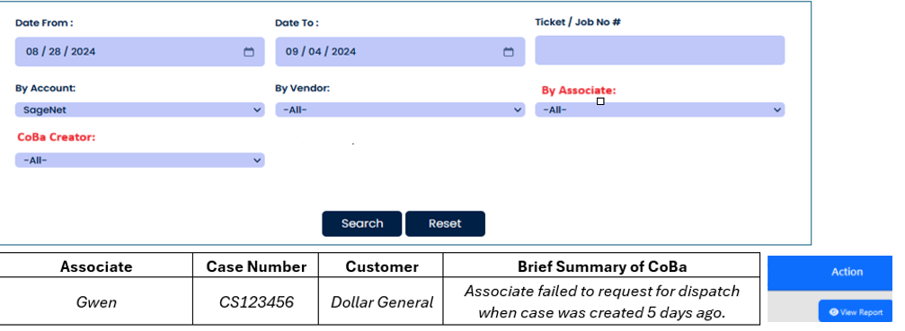

Please also include a link to download an Excel file including coaching notes for each Coach Back on this page.

