CallTek Engineering Request
System Type | CAS | Name of Requester | Alexis
Request Date | October 3, 2024 | Name of Engineer
Approved by |  | Approval Date

Task
Identified Issue or Feature request | Zabbix to CAS Integration
Goal | To better manage and monitor Alerts through CAS instead
Root Cause and Findings | INITIAL EMAILS (OUTAGE NOTIFICATION)  - Once a ticket appears in CAS, an outage notification should be sent after the following durations:  - Gateway, Firewall, Switches: 10 minutes  - Access Points (AP) = 15 minutes  Note: Email templates will be provided once our client completes their review.  - For the outage notification recipient/s, the system will get the POC email addresses in SNAPx.  Note: We are still awaiting the API for this.  - The initial/outage notification should be sent from the ESM mailbox: ESM@safetynetaccess.com  FOLLOW-UP EMAILS  - The system should automatically send a follow-up email if there is no ticket activity or update by the agent in CAS after the outage notification has been sent. The follow-up intervals are as follows:  - Omni sites: Every 2 hours  - All other brands: Every 3 hours  - The system should automatically send a follow-up email based on the agent’s ticket notes. An AI program will summarize the ticket notes and generate the email.  - Trigger: CAS will send the email if the “Notify Customer” option is selected. Once the agent clicks “Save Change,” the system will send the follow-up email.  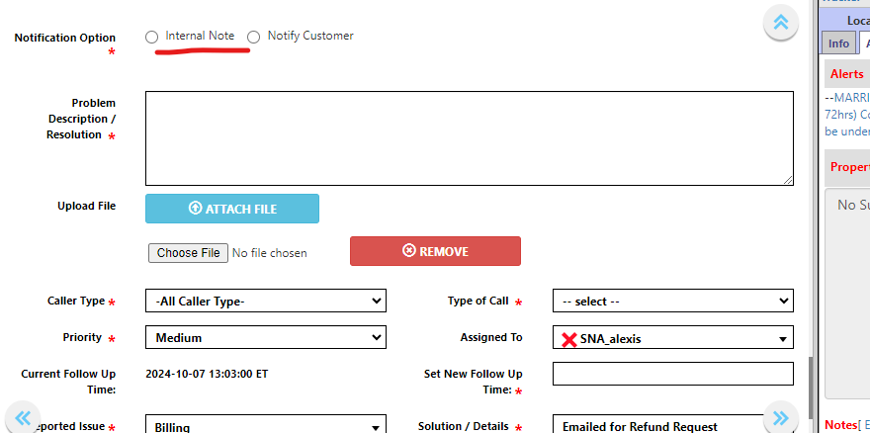  - The system should still allow us to send personalized emails using the “Send an Email” or “Reply to Email” options.  - All follow-up emails should be sent from the property’s brand-specific email address. For example, if the site is a Hilton property, the email should come from SNA_Hilton@safetynetaccess.com.  TICKET CLOSURE EMAILS  - As soon as a ticket is set to “Resolved,” the system should send a ticket closure notification. (Email templates will be provided once our client completes their review.).  - Trigger The email will be sent if the “Notify Customer” option is selected in CAS. Once the agent clicks “Save Change,” the system will send the ticket closure email.  ** Not all tickets set to “Resolved” will trigger a ticket closure notification. Some tickets may be closed during the initial check if they resolve on their own.  SAMPLE SCENARIOS  - SCENARIO 1  - CAS receives a ticket for a Sonesta server down.  - After 15 minutes, the system sends an outage notification.  - 30 minutes later, the agent performs an initial check, troubleshoots, and attempts to contact the site. She selects "Notify Customer" and saves her notes. The system sends a follow-up email.  - 3 hours later, with no activity from the agent, the system sends another follow-up email using the template.  - 1 hour after the automated follow-up, the agent makes another attempt to resolve the issue, works with the site, and saves her ticket. The system sends another follow-up email  - A few minutes later, the agent sets the ticket to "Resolved," and the system sends the ticket closure email.  - SCENARIO 2  - CAS receives a ticket for a Sonesta switch down.  - After 15 minutes, the system sends an outage notification.  - After 3 hours, the system sends an automated follow-up email since there was no activity in the ticket.  - After 30 minutes, the agent works on the ticket and contacted the site but to no avail. The agent selected ‘Notify Customer’ and saved the ticket. The system sends the follow-up email.  - After 1 hour, the agent worked again on the case and got the issue resolved. The agent selected ‘Notify Customer’ and saved the ticket. The system sends the follow-up email.  - A few minutes later, the agent sets the ticket to "Resolved," and the system sends the ticket closure email.
Fix implemented
Regression Test Performed
Side effects of Fix
Solution Acceptor Comments

