CallTek Engineering Request
System Type | CAS | Name of Requester | Shelley
Request Date | Oct 15, 2024 | Name of Engineer
Approved by |  | Approval Date

Task
Identified Issue or Feature request | To convert to PDF file for all images, Screenshots, pictures attached / copy pasted to the body of the mail in CAS.
Goal | To ensure that the image/screenshot/picture will be visible, zoomable and readable
Root Cause and Findings | When an agent copy pasted an image, picture, screenshot in the body of the email in CAS it will convert to PDF file.  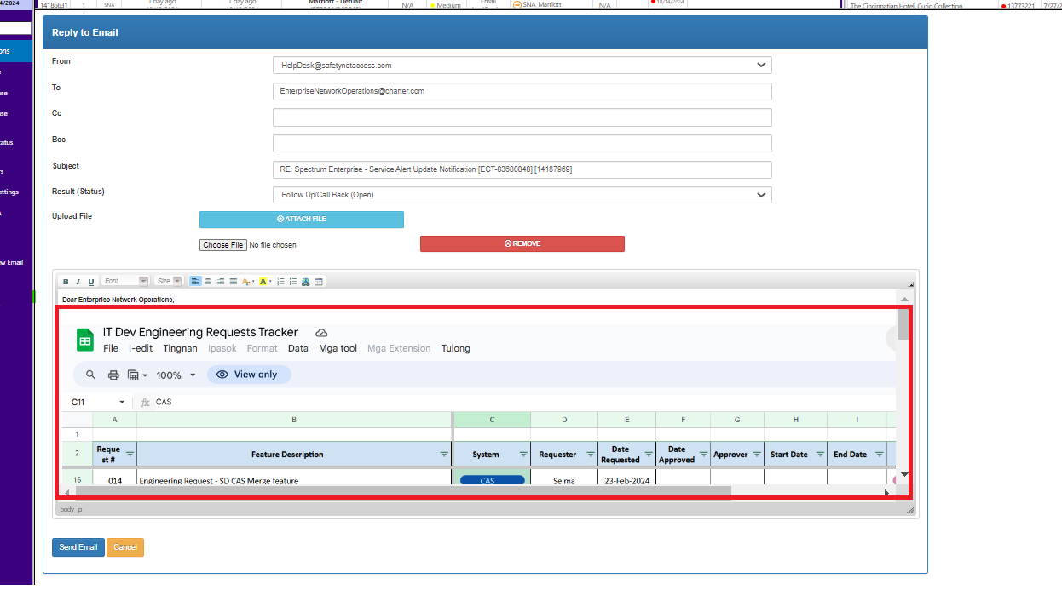
Fix implemented
Regression Test Performed
Side effects of Fix
Solution Acceptor Comments

