CallTek Engineering Request
System Type | QIS | Name of Requester | Gwen
Request Date | Nov. 5, 2024 | Name of Engineer | IT DEV
Approved by |  | Approval Date

Task
Identified Issue or Feature request | Additional features were discovered to be useful upon the live date of SageNet’s CoBa in QIS.  - Leaders and supervisors will have the ability to add CoBa to several associates at once. Sometimes more than one associate need mentoring for a single case.  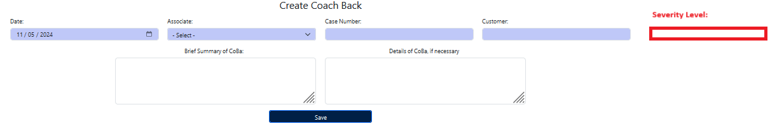  - To add Severity Level when adding CoBa. Severity Level should also appear under View Report.  Options are:  Severity 1  Severity 2  Severity 3
Goal | To make use of QIS for coaching opportunities for both CallTek and stateside associates.
Root Cause and Findings
Fix implemented
Regression Test Performed
Side effects of Fix
Solution Acceptor Comments

