CallTek Engineering Request
System Type | CAS | Name of Requester | Alexis
Request Date | November 13, 2024 | Name of Engineer
Approved by |  | Approval Date

Task
Identified Issue or Feature request | - Add additional fields/drop-down in CAS for the reported issues and solutions  - Hide all the old reported issues and solution/details (effective Dec 1st)  - Bulk upload the new reported issues, details, root cause and solutions. Please check the attached file.
Goal | The additional fields will improve reporting and data analysis by being able to get the specifics and root cause of the issue.
Root Cause and Findings | - The 2 additional drop downs are “Details” and “Root Cause”.  - We will also be renaming Solution/Details to just Solution.  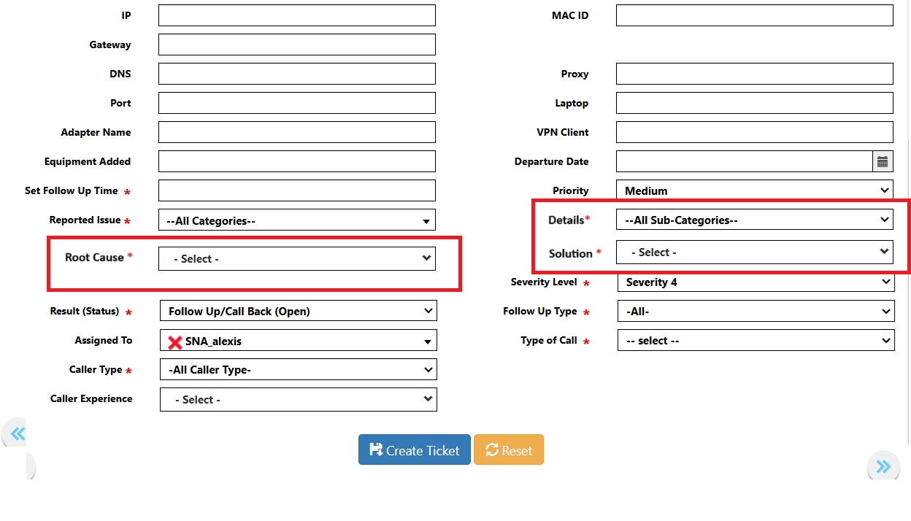  - With the implementation of the new reported issues and solutions, we will need to hide all existing/old reported issues and solutions. This is so not to impact the historical data.  - We also need help in doing a bulk upload of all the new reported issues, details, root cause and solutions (if this is an option).
Fix implemented
Regression Test Performed
Side effects of Fix
Solution Acceptor Comments

