CallTek Engineering Request
System Type | CAS | Name of Requester | Alexis
Request Date | November 20, 2024 | Name of Engineer
Approved by |  | Approval Date

Task
Identified Issue or Feature request | - Add a Timer to Determine the Elapse Time/Ticket Age of Severity 1-3 Cases  - Add a column for the Ticket Age on the Open Tickets (Age) screen list of tickets.
Goal | To efficiently monitor and track ticket age/elapsed time, helping to prevent SLA breaches and prioritize tickets effectively
Root Cause and Findings | - To ensure we avoid SLA breaches, implement a timer (format to be used is hh:mm:ss) that tracks the ticket age for open tickets (format to be used is hh:mm:ss).  - The ticket age is based on the date and time the ticket was created.  - This timer should be integrated into the Actual Ticket View (when a ticket is opened/viewed)  - Suggestion on where to place the timer is below. That’s the ideal place because even when we scroll through the ticket, it stays.  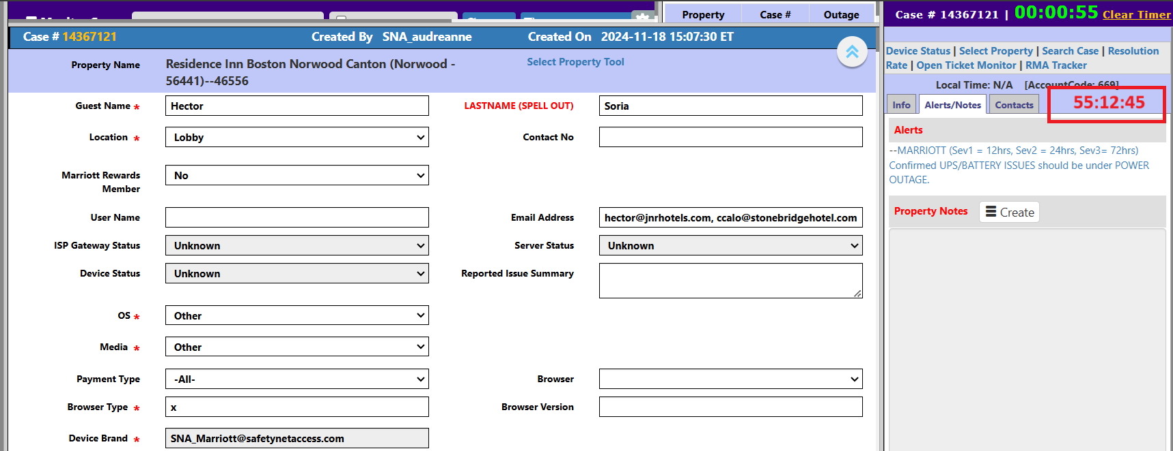  - The color of the timer will change based on various levels of its severity:  - Severity 1  - 00:00:00-04:00:00 – Green  - 04:00:01-08:00:00 – Yellow  - 08:00:01-10:00:00 – Violet  - 10:00:01-12:00:00 – Orange  - Over 12 hours – Red  - Severity 2  - 00:00:00-06:00:00 – Green  - 06:00:01-14:00:00 – Yellow  - 14:00:01-20:00:00 – Violet  - 20:00:01-24:00:00 – Orange  - Over 24 hours – Red  - Severity 3  - 00:00:00-24:00:00 – Green  - 24:00:01-48:00:00 – Yellow  - 48:00:01-60:00:00 – Violet  - 60:00:01-72:00:00 – Orange  - Over 72 hours – Red  - Add a column for the Ticket Age on the Open Tickets (Age) screen list of tickets  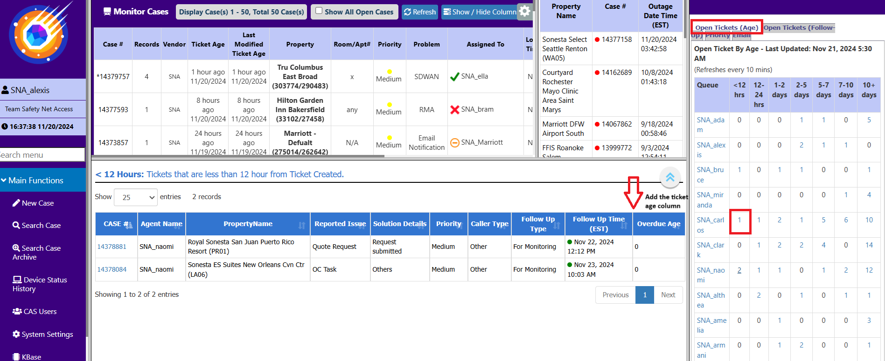
Fix implemented
Regression Test Performed
Side effects of Fix
Solution Acceptor Comments

